Modeling of Telecommunication CDRs in a Time Series dataset

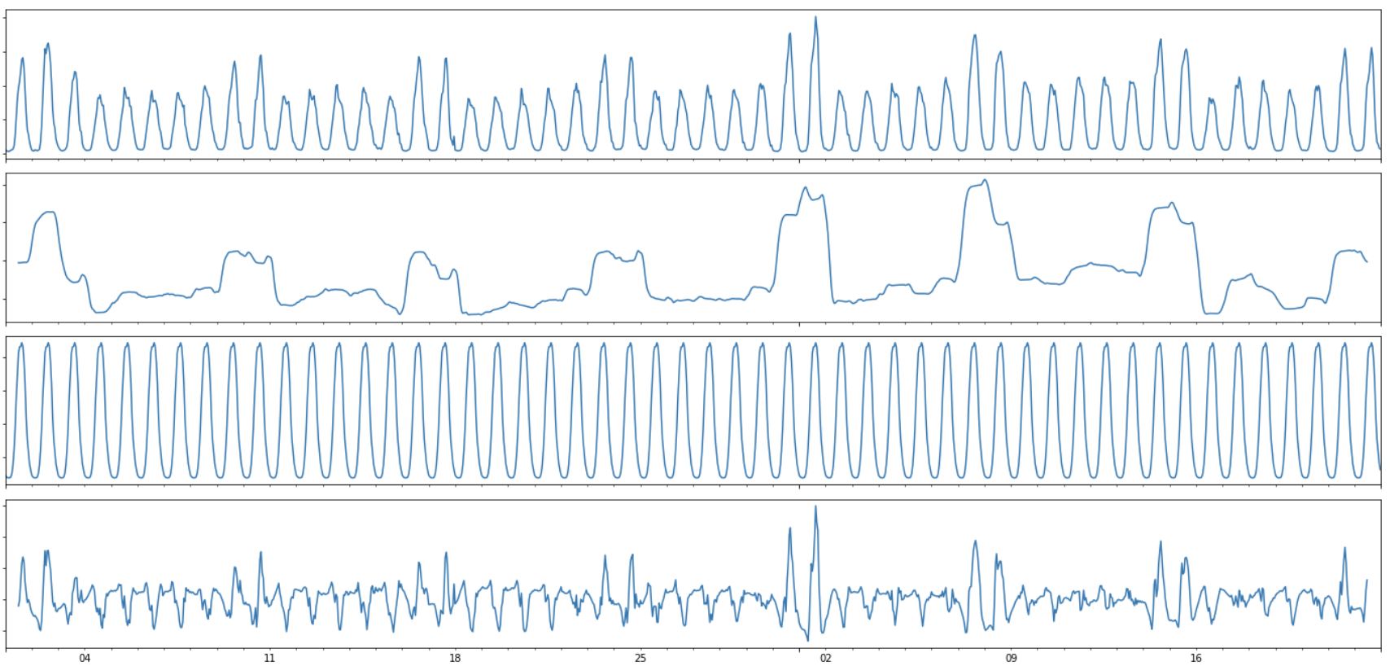

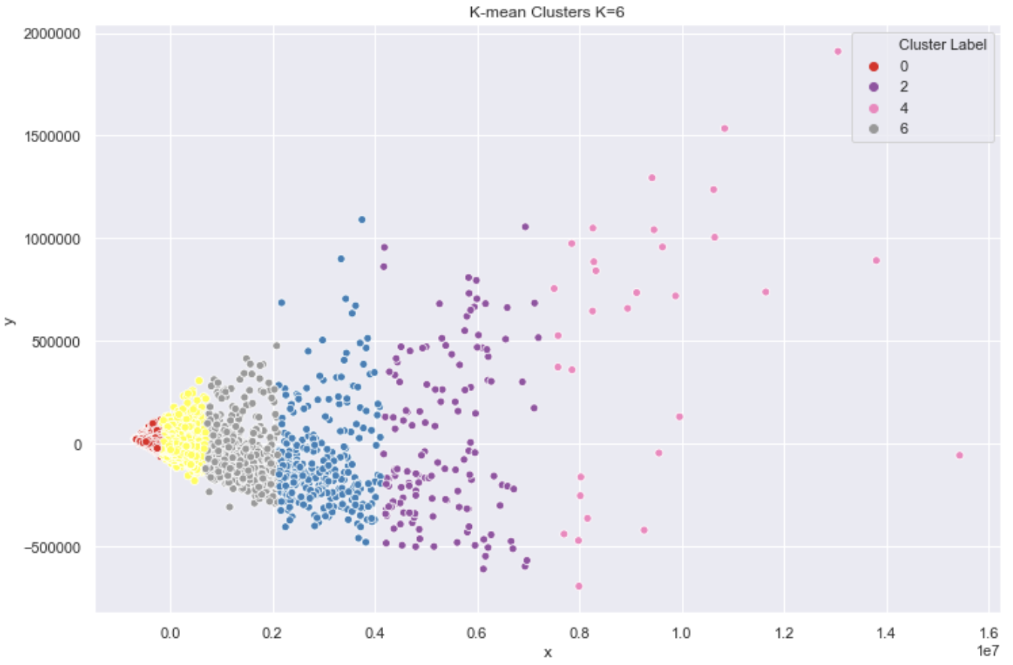

By,

Aruna Subbiah

Table of Contents

1. CDR 3

**Problem Statement** 3

**Data Description** 3

2. DATA WRANGLING 5

**Reading data into Pandas DataFrame** 5

**Handling Datetime column** 5

**Removing unwanted columns** 5

**Resampling** 5

3. EXPLORATORY DATA ANALYSIS 7

**Visualization of Grids** 7

**Top 10 Grids** 8

**Grid’s Telecommunication Activity Pattern** 11

Daily Activity Plots 12

Hourly Activity Plots 14

Day of Week Plots 16

4. FEATURE ENGINEERING 18

5. MACHINE LEARNING: K-MEANS CLUSTERING 21

**Finding the Optimal K value** 21

Elbow Method 21

Kneed package 22

Silhouette coefficient plot 22

**K-Means Clustering** 24

**Visualization of K Clusters** 24

Principal Component Analysis 24

GEOJSON 25

**Analysis of K Clusters** 26

6. MACHINE LEARNING: TIME SERIES FORECASTING 31

**SARIMA Model** 31

Time Series Decomposition 32

Hyperparameter Tuning 32

Model Evaluation 36

7. CITATIONS 37

8. REFERENCES 37

# CDR

The exponential increase in the use of internet services and mobile phones is generating large amount of data that can be used to provide useful insights about the network usage pattern. Call Detail Record [CDR] describes a specific instance of a telecommunication transaction that passes through a network element. Every time a user performs a telecom activity such as send/receive SMS and calls, a CDR is generated. It contains information about the caller/sender ID, location, time, data used, etc. Millions and millions of such records are generated and is mainly used for billing purposes by the telecom company.

## **Problem Statement**

Analysis and modeling of this time series data helps to identify geographical boundaries of various usage patterns. This helps in decision making of resource allocation by telecommunication companies who own the network elements, inspecting quantitatively different aspects of human behavior such as socio-economic status of geographical regions and people's mobility. CDRs collected for a span of time can also be used in forecasting future volumes for a network.

## **Data Description**

This dataset is a part of Telecom Italia Big Data Challenge which is an aggregation of telecommunications, weather, news, social networks and electricity data from the city of Milan and the Province of Trentino. This dataset has been released to the research teams under the Open Database License (ODbL) and is maintained by Harvard Dataverse.

For this project we will use telecommunication data from the city of Milan, Italy. It is available as .txt files with tab-delimited values (TSV) from the link,  <https://doi.org/10.7910/DVN/EGZHFV>.

There are 62 files consisting of CDRs collected from Nov 1,2013 to Jan 1, 2014, one file for each day.

File size: ~ 200MB – 300MB with ~4 million rows each file

Files: sms-call-internet-mi-2013-11-01.txt to sms-call-internet-mi-2014-01-01.txt

There are 8 columns, with no headers. Each column represents,

* Grid id: identification string of a given square of Milan GRID. The geographical region of the city is spatially divided into 1000 square grids.
* Time Interval: start interval time expressed in milliseconds. The end interval time can be obtained by adding 600,000 milliseconds (10 min) to this value.
* SMS-in activity: activity proportional to the amount of received SMSs inside a given Square id and during a given Time interval. The SMSs are sent from the nation identified by the Country code.
* SMS-out activity: activity proportional to the amount of sent SMSs inside a given Square id during a given Time interval. The SMSs are received in the nation identified by the Country code.
* Call-in activity: activity proportional to the amount of received calls inside the Square id during a given Time interval. The calls are issued from the nation identified by the Country code.
* Call-out activity: activity proportional to the amount of issued calls inside a given Square id during a given Time interval. The calls are received in the nation identified by the Country code.
* Internet traffic activity: number of CDRs generated inside a given Square id during a given Time interval.
* Country code: the phone country code of the nation.

Each observation holds information about the volume of telecommunication activities performed over the next 10 min.

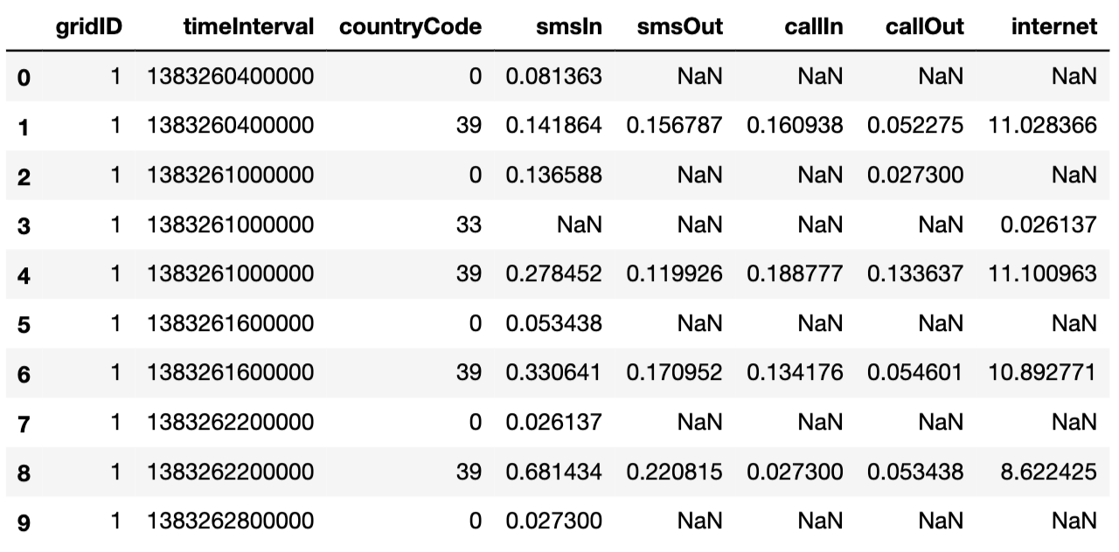

*Fig 1: Data as read from the input files*

As the original bundle of dataset comes from various companies (telecommunications, weather, news, social networks and electricity) with different standards, in order to ease the comparisons of different geographical areas, the city of Milan’s spatial distribution is aggregated in a grid with 10,000 square cells. The area is composed of a grid overlay of 10,000 squares with size of about 235×235 meters. This dataset provides the geographical reference of each square which composes the grids in the reference system: WGS 84—EPSG:4326. It is downloaded from the link, <https://doi.org/10.7910/DVN/QJWLFU>.

File type: geojson

File size: 3MB

File: milano-grid.geojson

Columns:

* *square id*: identification string of a given square of the Milan GRID;
* *Time Interval*: The cell geometry expressed as geoJSON and projected in WGS84 (EPSG:4326).

# DATA WRANGLING

## **Reading data into Pandas DataFrame**

Reading 20GB of data from 62 files iteratively and combining them into a single dataframe takes about 30 min and utilizes very high system memory. Alternatively, reading a file into a dataframe, perform operations like sampling [daily, hourly], grouping & indexing that reduces the number of rows and combining these individual data frames into a single dataframe results in a faster and efficient loading operation.

## **Handling Datetime column**

Time Interval column is represented in milliseconds, as epoch/Unix timestamps. It is the number of milliseconds passed since 00:00:00 UTC Thursday, 1 January 1970. This column values are converted to pandas Datetime object which is passed to Pandas in built Datetime functions to convert to Milan's local time zone. This value is stored in a new column, startTime.

## **Removing unwanted columns**

Time Interval column now has redundant values and Country code column will not be used in this project. They are both dropped from the data frame.

## **Resampling**

Several rows of data, with 10 min time interval are aggregated into DataFrames with daily (24 hour) and hourly time intervals. They are grouped and indexed by Grid ID & startTime columns. Total volume of each activity over the 2 months for individual grids is calculated in another DataFrame. Because rows are aggregated into hourly, daily and total volumes there are no NaN values.

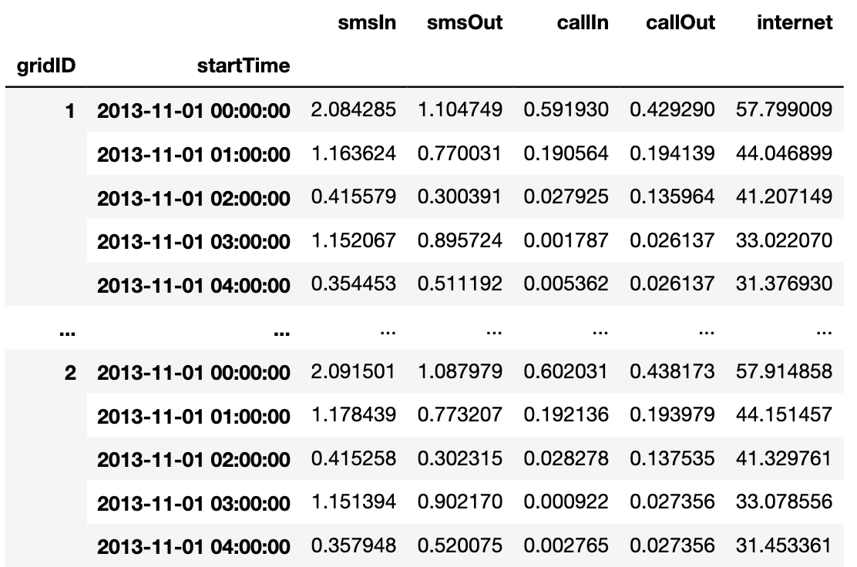

*Fig 2: DataFrame with hourly aggregation of telecommunication activities for each grid*

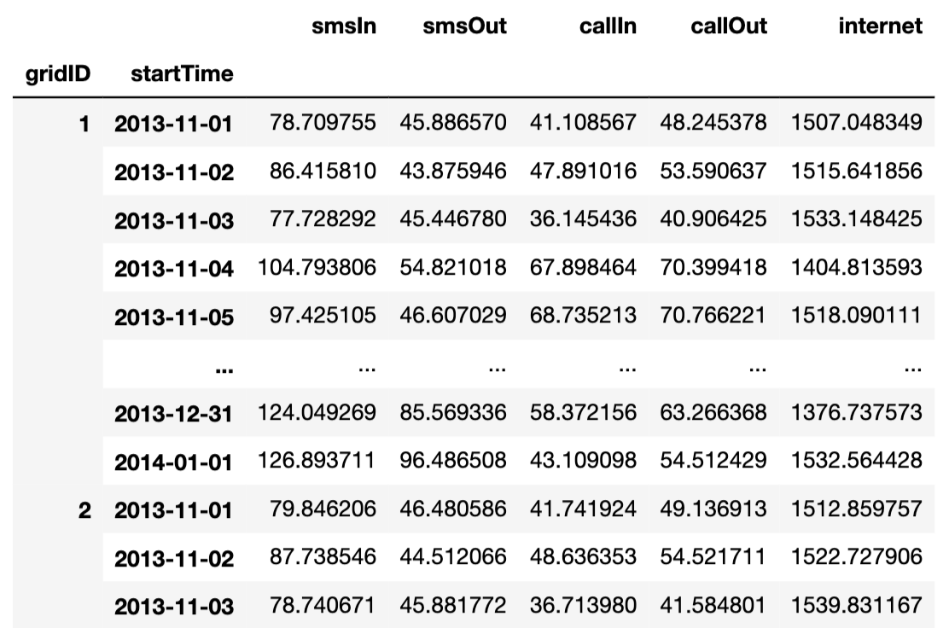

*Fig 3: DataFrame with daily aggregation of telecommunication activities for each grid*

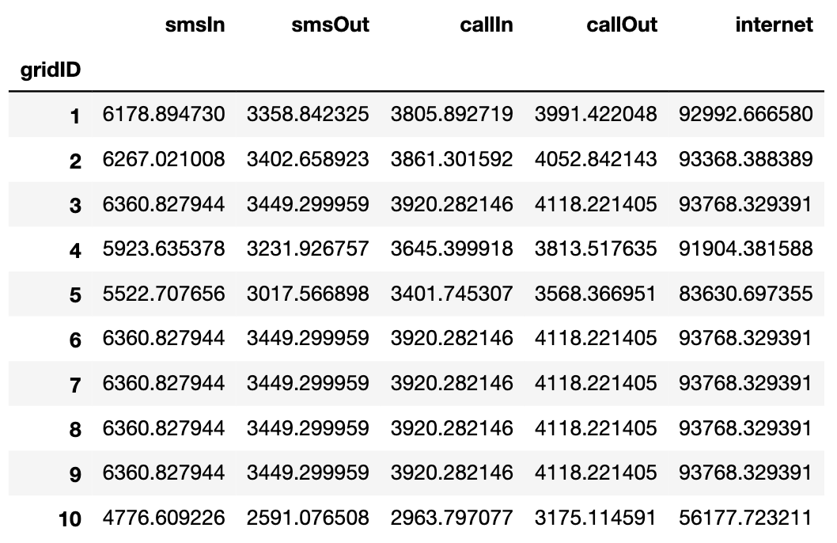

*Fig 4: DataFrame with total volume of telecommunication activities over the 2 months for each grid*

# EXPLORATORY DATA ANALYSIS

## **Visualization of Grids**

milano-grid.geojson file is loaded using packages geopandas & geojsonio that shows the overlay of 10000 grids over the city of Milan’s map.

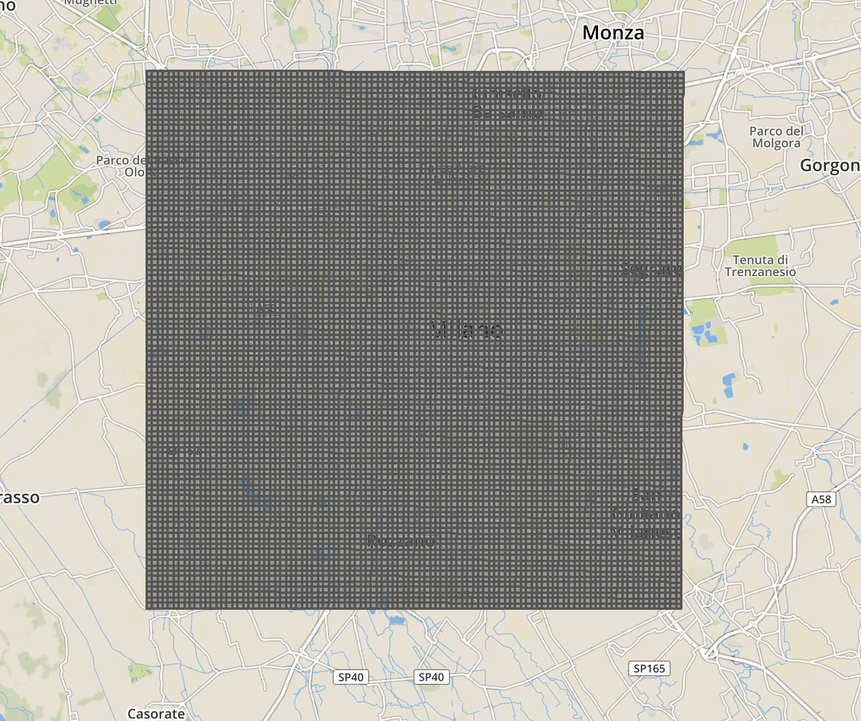

*Fig 5: Spatial aggregation of 10,000 grids over the city of Milan*

In the network, SMS-In and SMS-Out utilizes the control channel, Call-In and Call-Out utilizes transmitted over voice channel and the internet is transmitted over broadband frequencies. Thus, we will use SMS (sum of SMS-In & SMS-Out), Call (sum of Call-In & Call-Out) and Internet activity for the analysis.

## **Top 10 Grids**

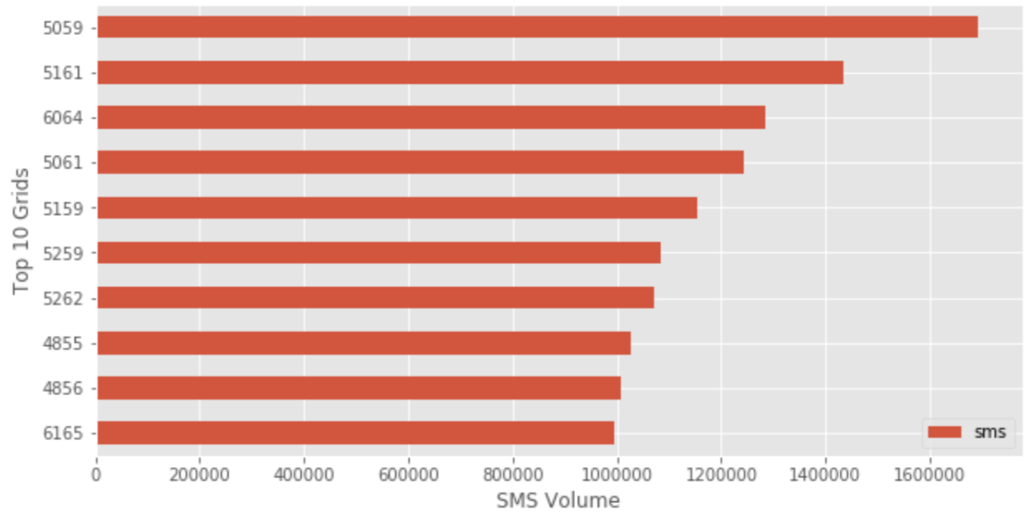

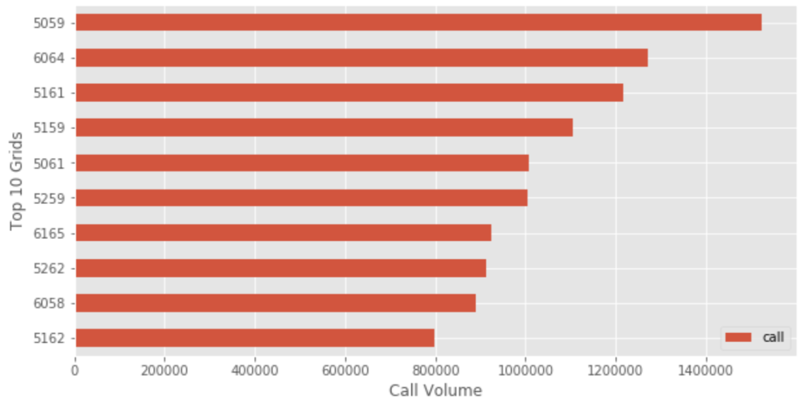

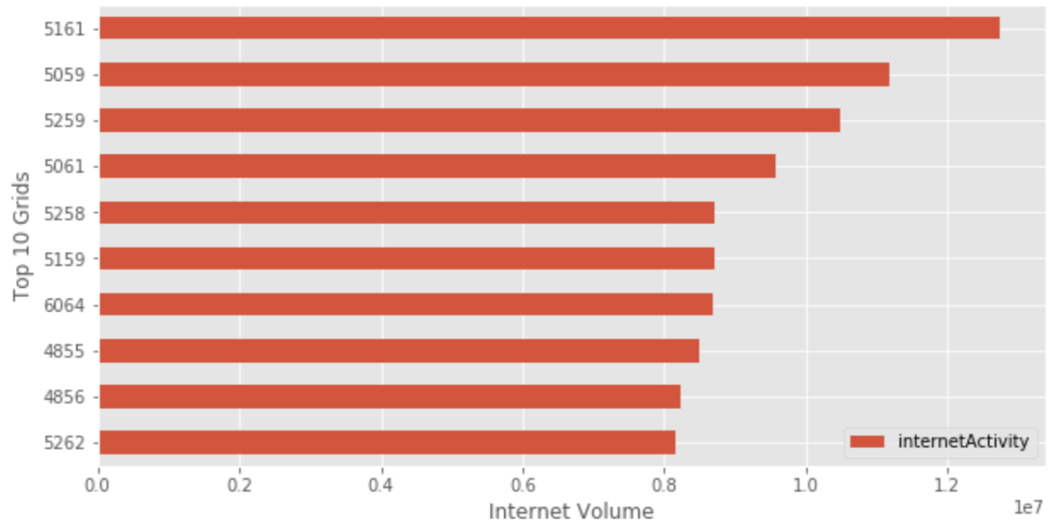

*Fig 6: Horizontal bar plots showing top 10 grids with high total volumes in each telecommunication activity*

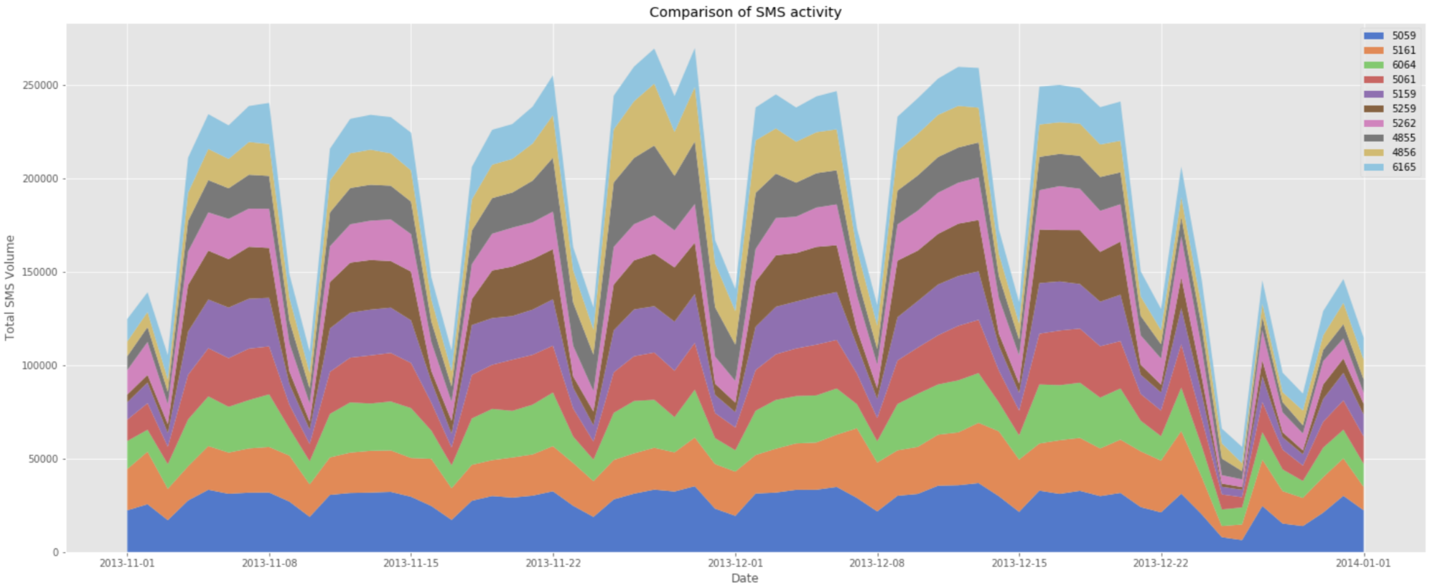

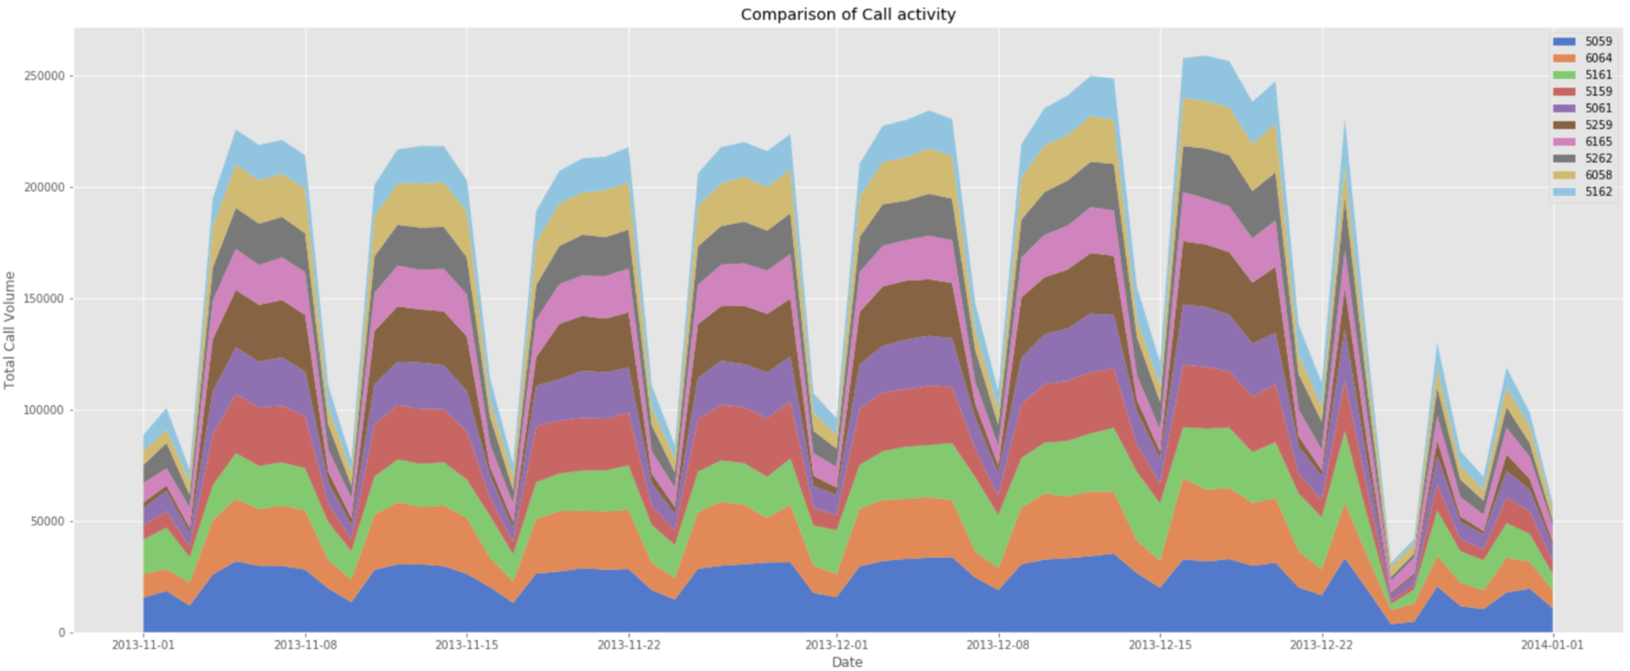

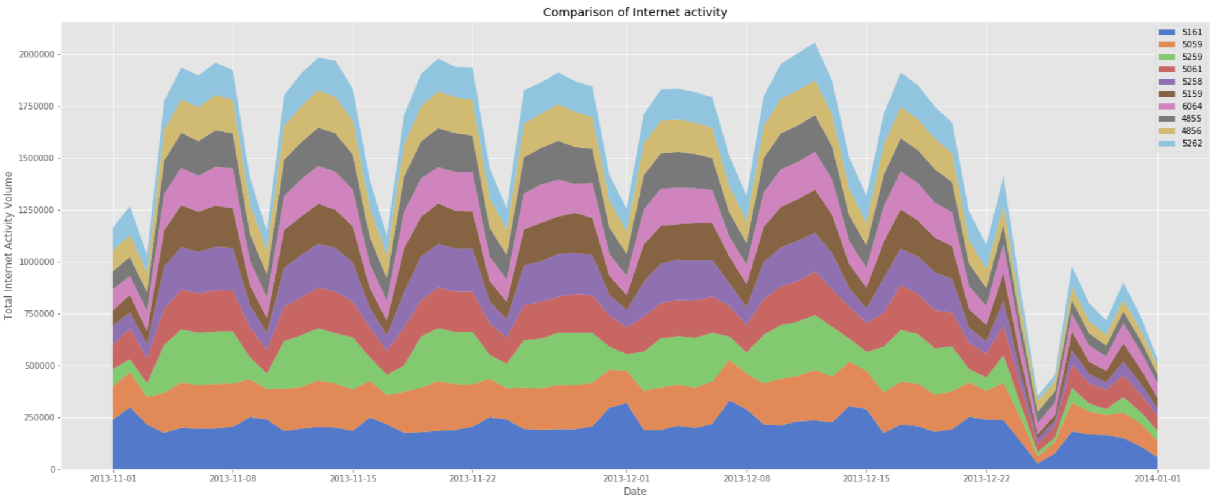

*Fig 7: Stacked area plots showing comparison of top 10 grids daily pattern*

Top 10 grids that experience high volumes for each of these activities for the 2 months are identified. From the above plots, we see that the first 4 grids have highly varying total volume and rest of the grids have almost same total volume for each activity. This is further verified by performing a set of one-way ANOVA tests [Fig 8].

P-value < 0.05 indicates mean values of the grids are not equal, P-value > 0.05 indicates means values of the grids are equal.

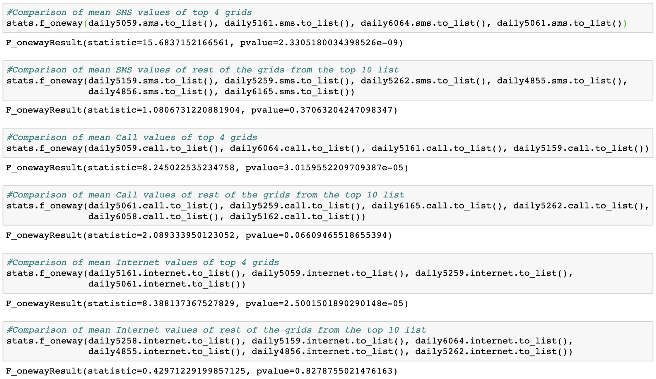

*Fig 8: One-Way ANOVA tests verifying that, except the first 4 grids, rest in the top 10 list have similar mean volumes*

Location of top 10 grids with highest volumes in the map shows that they are all from Duomo & Milano Centrale region.

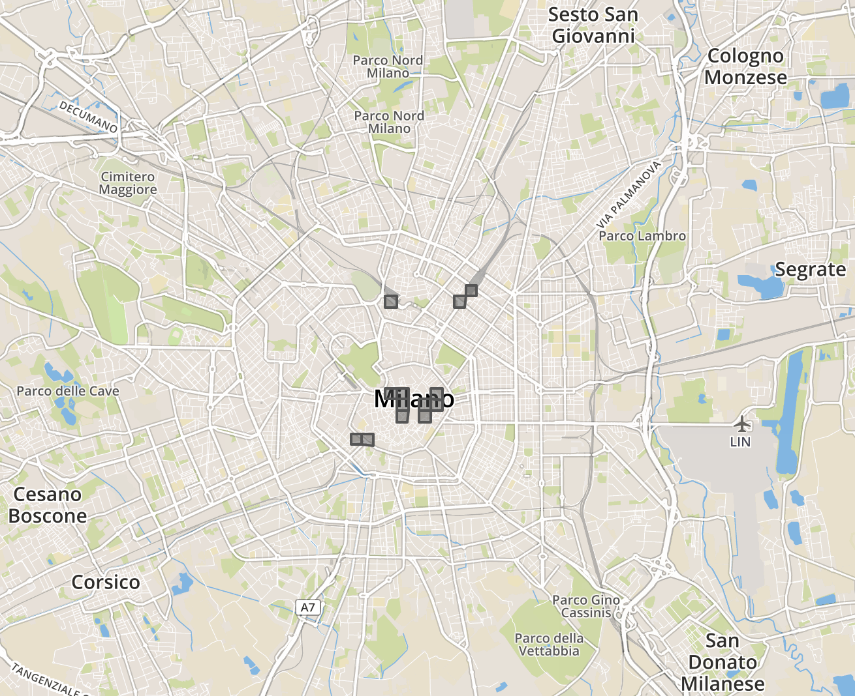

*Fig 10: Location of top 10 high-volume grids in the city map*

## **Grid’s Telecommunication Activity Pattern**

All the top contributing grids are from the city’s center and mostly near transport hubs, they are expected to show similar behavior and most of these grids have approximately same mean values. In order to capture variations in the city’s telecommunication activities, we will examine the following four grids that has markedly different behavioral signatures,

4459 - Bocconi, one of the most famous Universities in Milan

4456 - Navigli district, one of the most famous nightlife places in Milan

5060 - Duomo, the city center of Milan

5646 - Fiera, residential neighborhood of Milan

### Daily Activity Plots

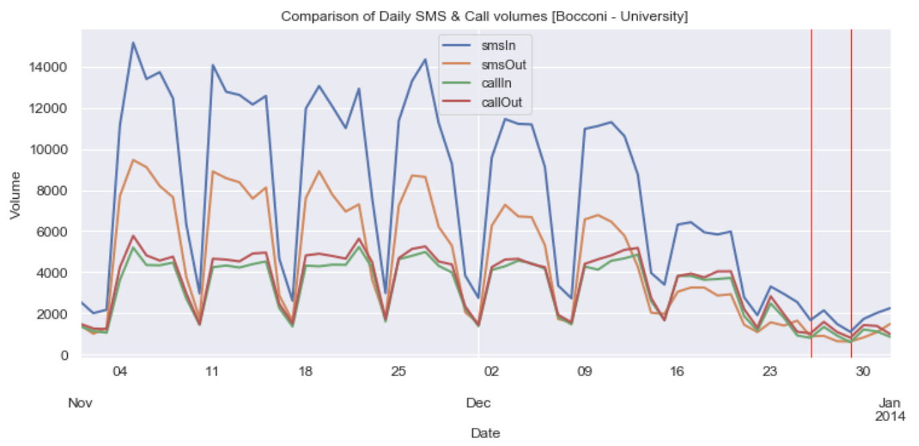

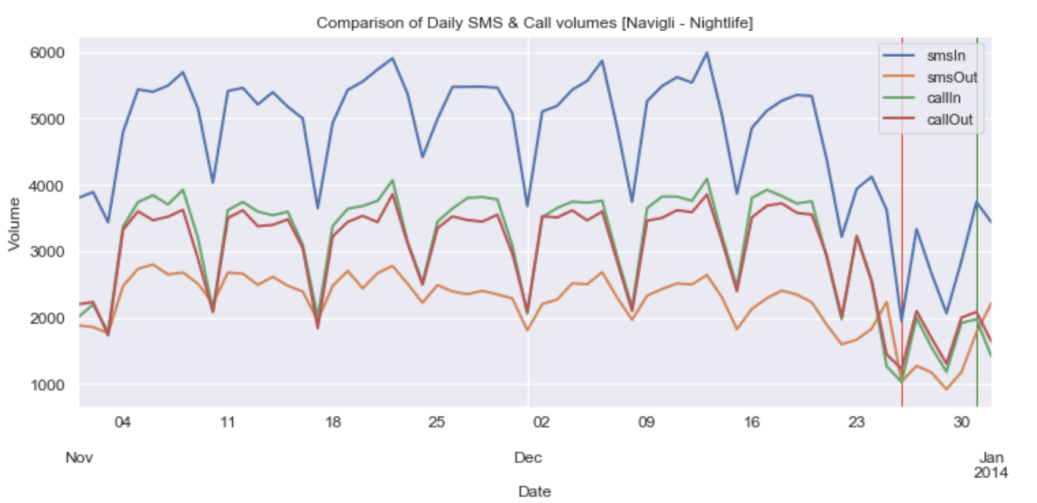

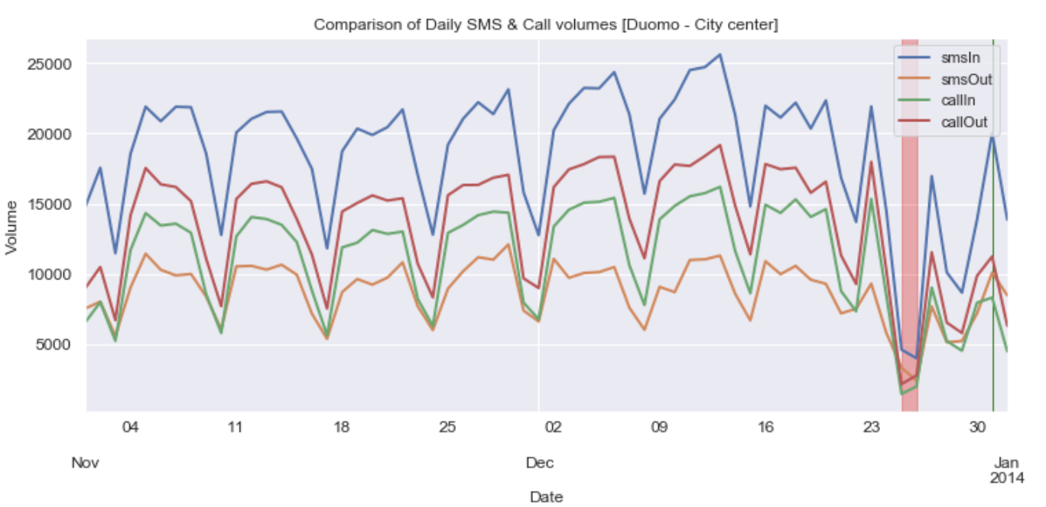

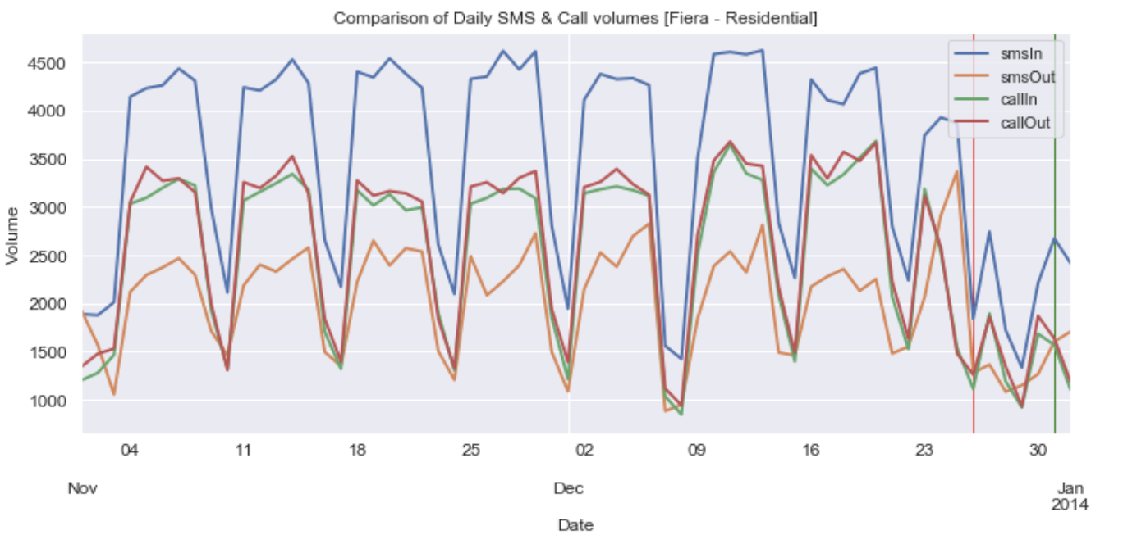

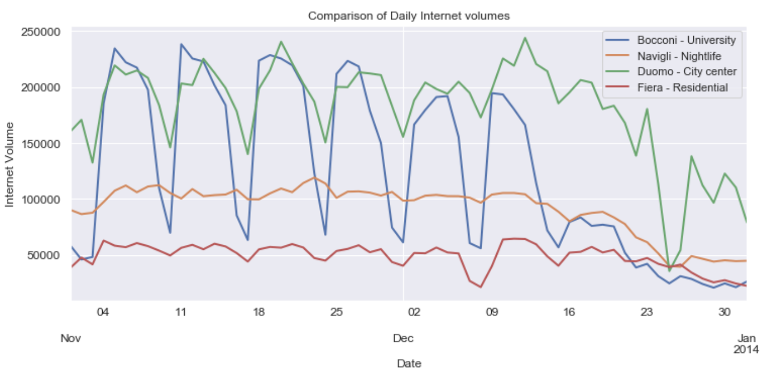

*Fig 11: Time-series plot of daily telecommunication activities of the four grids*

* All four grids have received high volumes of incoming SMS compared to other activities.

Outgoing SMS has the least volume, almost equal amounts of Calls are made and received.

* Duomo has highest volume of all activities, followed by Bocconi, then Navigli and Fiera in the end. We can order the grids based on total volumes as,

Duomo [city center] > Bocconi [university] > Navigli [nightlife] > Fiera [residential]

* All four grids exhibit seasonality in SMS & Call activities. In internet activity Navigli & Fiera doesn’t show any seasonality. This may because of IoT, with many devices always being connected to the network.
* There is a drop in the volumes towards December end in all the plots due to holiday season.
* The red line is significant drop in volume around Christmas and green line is a peak on New Year’s Eve. Note that Bocconi doesn’t show this peak indicating no mobility during New Year in that region.

### Hourly Activity Plots

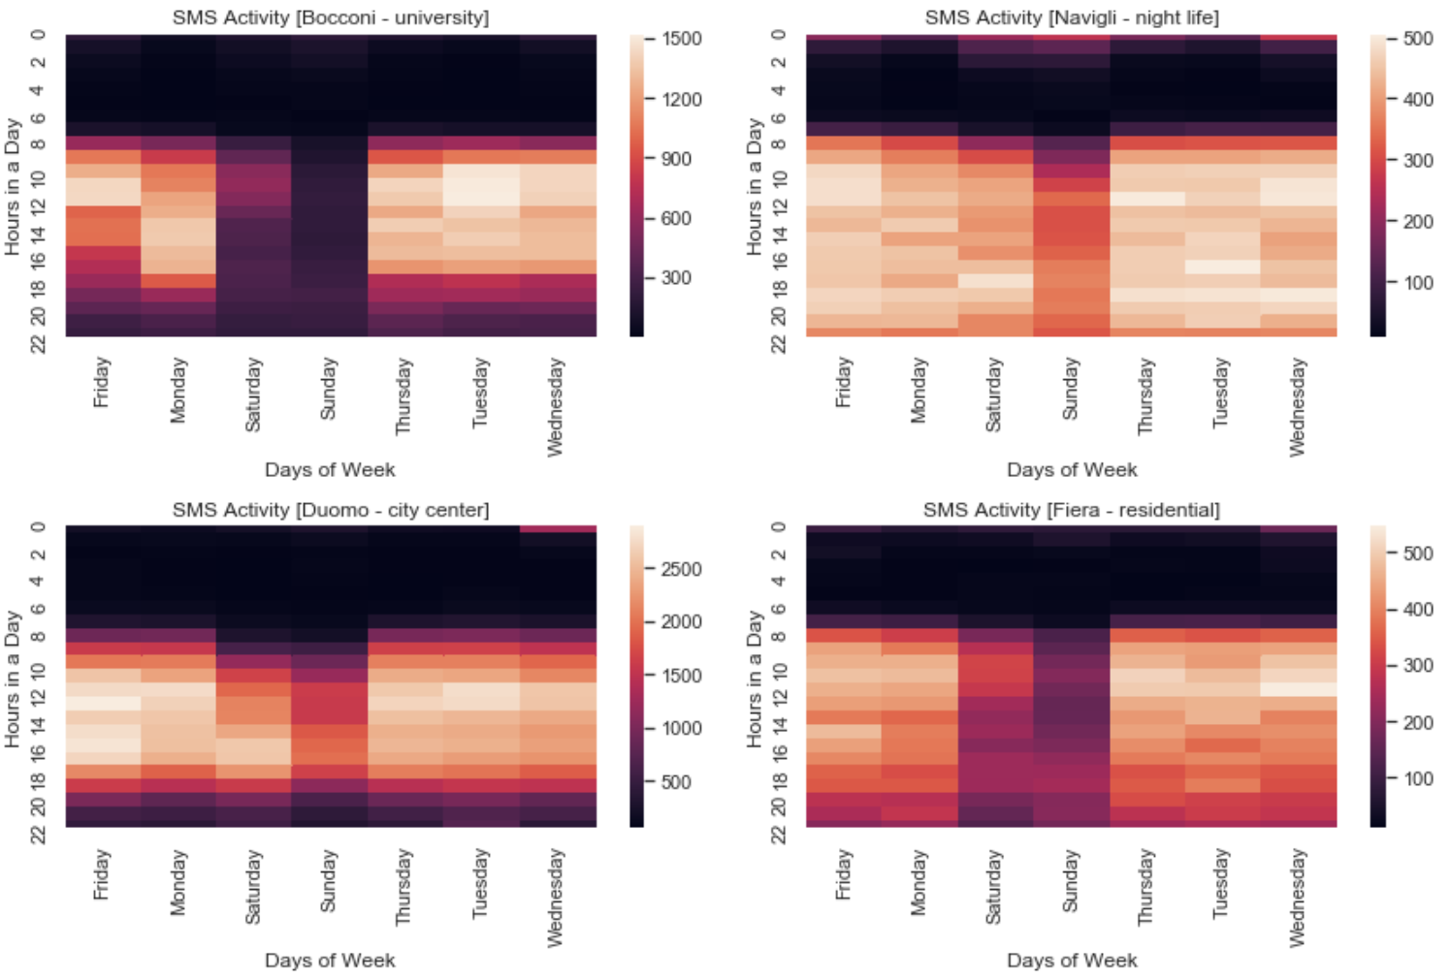

*Fig 12: Heat map of hourly SMS activity*

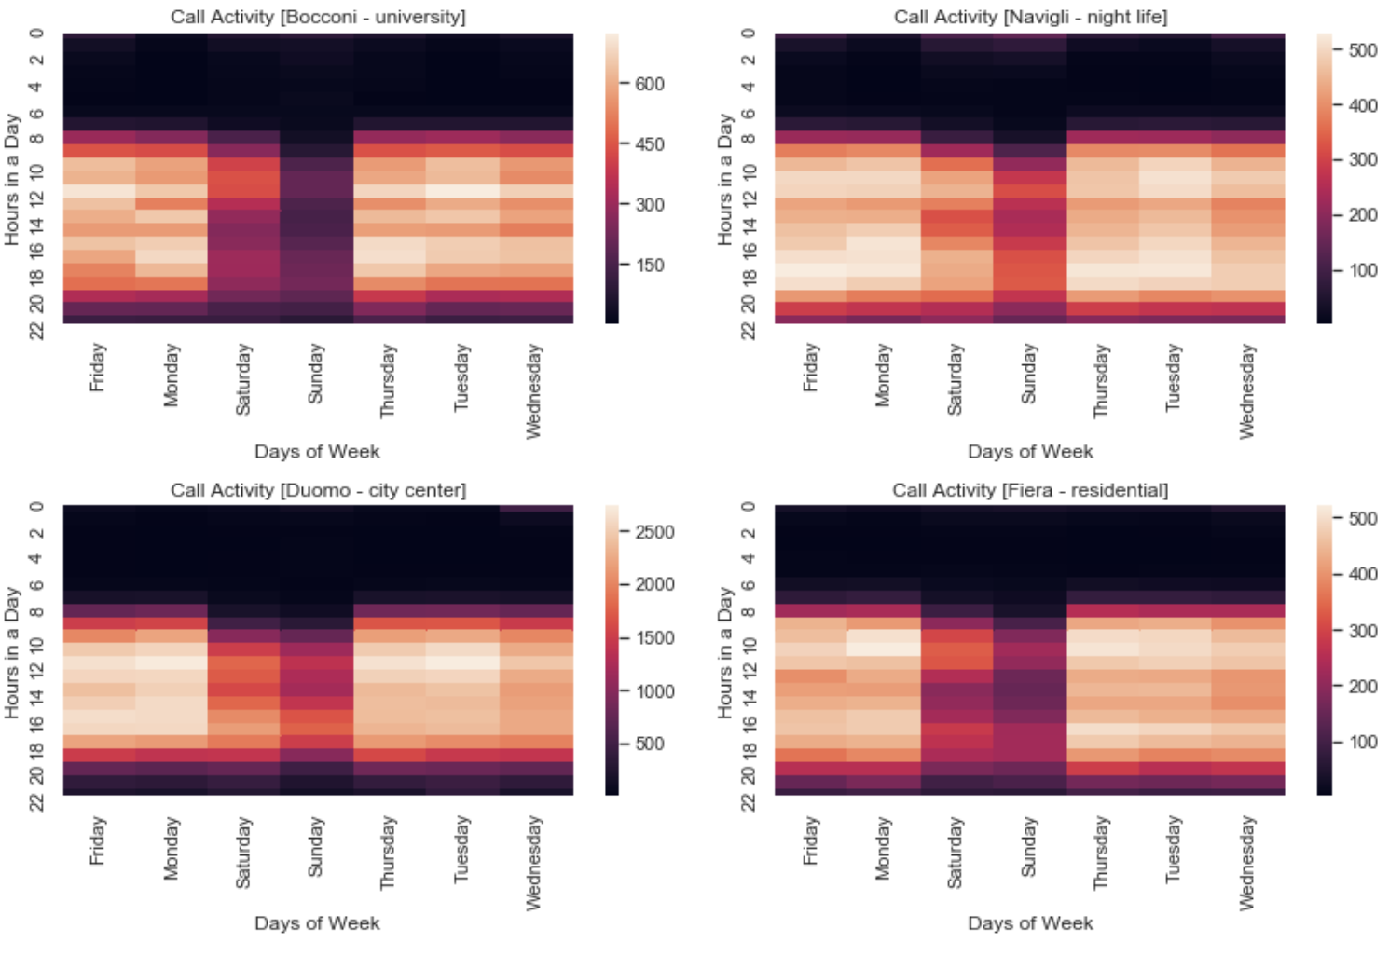

*Fig 13: Heat map of hourly Call activity*

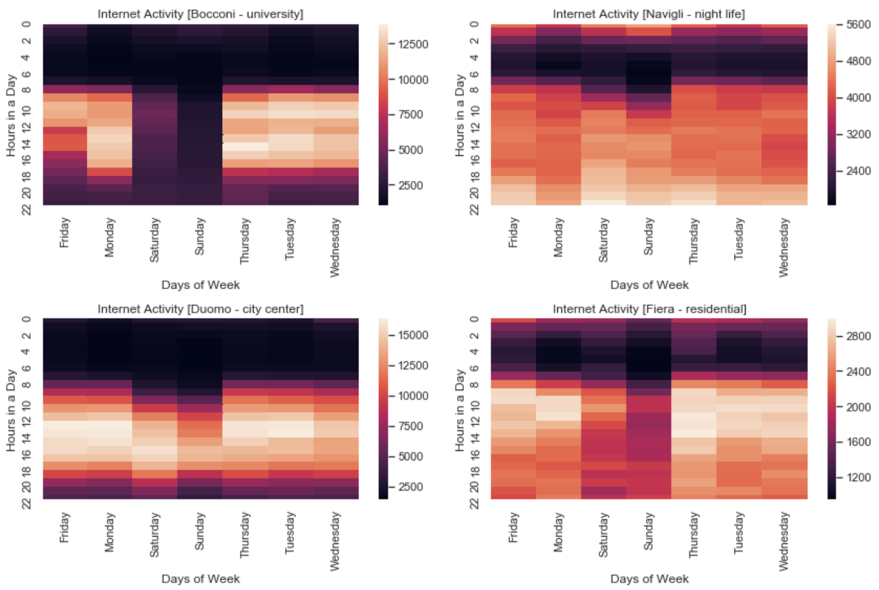

*Fig 14: Heat map of hourly Internet activity*

Heat maps shows significant differences in behavior of the four grids,

*SMS Activity:*

* In general, there is less SMS activities during the weekends (Saturday & Sunday).
* Navigli, night life region shows SMS activities until 2 am in the night on weekend.
* Fiera & Navigli regions are very active from 7am till 10pm on all days.
* Duomo, city center has very less SMS activity from 10pm until 7am in the morning on weekdays and 9 am on weekends.
* Bocconi, university shows less SMS activity compared to others.
* Navigli, Duomo & Fiera shows a bright region on Wednesday 12am, this must be due to New Eve falling on Tuesday.

*Call Activity:*

* Call activity has similar pattern as SMS, but lesser volumes.
* Surprisingly, there is no significant call activity on New Year eve. This shows how people are more connected via SMS and internet these days. Another possibility is that calls may have been made via internet.

*Internet:*

* Navigli & Fiera has internet activities almost all through the night. Even Bocconi, university shows some sparse activity after midnight on weekends.
* Duomo, city center although has the highest internet volumes, shows a steady pattern for all activities, 8am – 10pm on weekdays and 10am to 10pm on weekends.

### Day of Week Plots

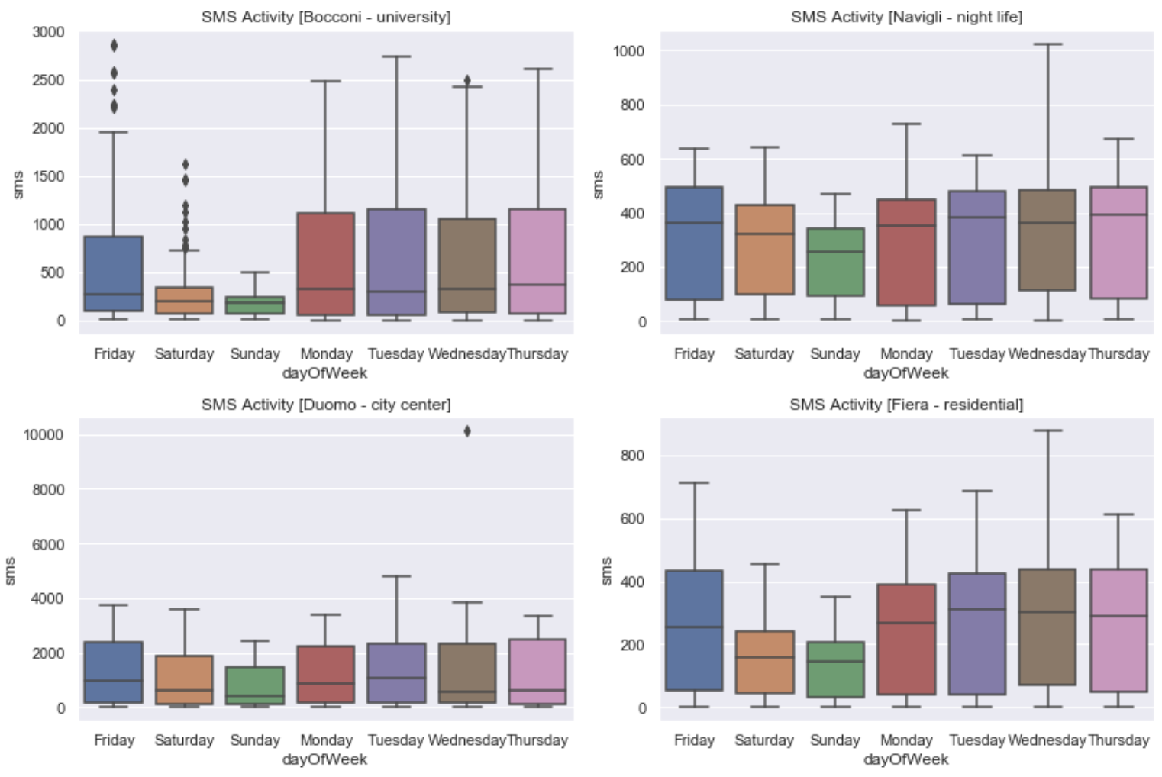

*Fig 15: Box plot of SMS activity for each day of the week*

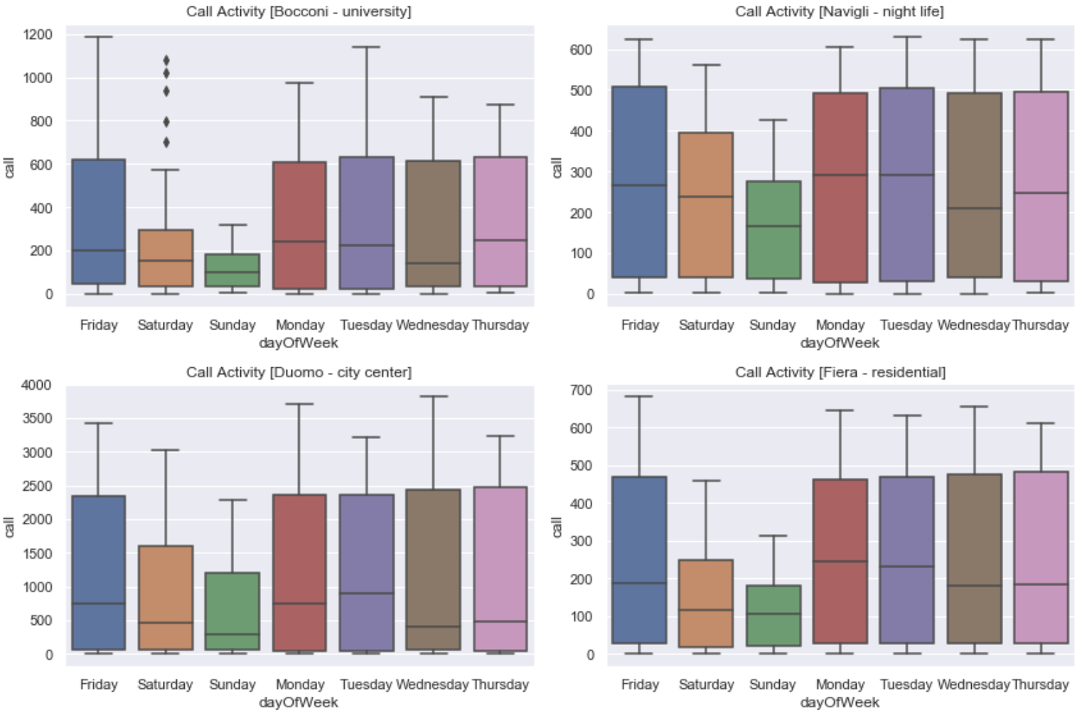

*Fig 16: Box plot of Call activity for each day of the week*

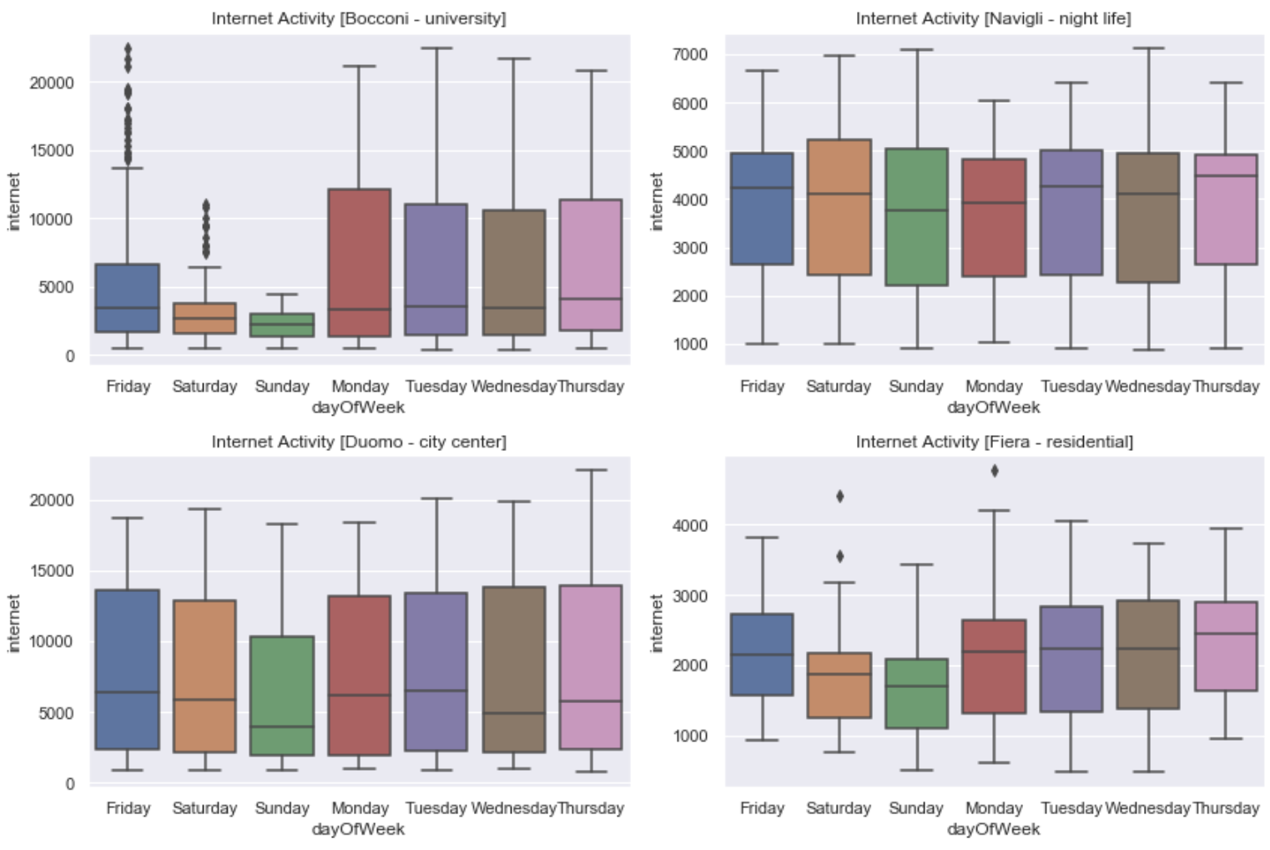

*Fig 17: Box plot of Internet activity for each day of the week*

*SMS Activity:*

* Bocconi has outliers on Friday & Saturday.
* Least volumes of SMS on Sunday for all four grids.
* Also, Bocconi shows significant difference between weekday and weekend volumes, followed by Fiera.

*Call Activity:*

* Again, Bocconi has some outliers on Saturday.
* Navigli & Fiera has almost equal call volumes on weekdays. They differ quite a lot on weekends.

*Internet Activity:*

* Navigli has approximately same median for all days.
* Bocconi also has same medians but the amount of activity varies for each day.

# FEATURE ENGINEERING

Our original dataset is a time series data with 5 features; smsIn, smsOut, callIn, callOut and internet volumes. For clustering our 10,000 grids into different groups, we will convert this time series data into grid-wise data. Creating a total of smsIn, smsOut, callIn, callout and internet volumes for each grid will have very minimal information about the behavior patterns of a grid’s telecommunication activities. Hence, we will perform Feature Engineering which is nothing but extracting more information from the existing data that helps Clustering algorithm to understand each grid better.

We have created a total of 101 features that are indexed by grid id.

|  |  |
| --- | --- |
| Features | *Description* |
| Weekend Hourly: |  |
| hourlysmsMax_WE  hourlycallMax_WE hourlyinternetMax_WE | Maximum hourly volume of SMS sent and received, call made and received, internet accessed during weekend |
| hourlysmsMin_WE  hourlycallMin_WE  hourlyinternetMin_WE | Minimum hourly volume of SMS sent and received, call made and received, internet accessed during weekend |
| hourlysmsAvg_WE  hourlycallAvg_WE  hourlyinternetAvg_WE | Average hourly volume of SMS sent and received, call made and received, internet accessed during weekend |
| Weekend Daily: |  |
| smsMax_WE  callMax_WE  internetMax_WE | Maximum daily volume of SMS, Call & Internet during weekend |
| smsMin_WE  callMin_WE  internetMin_WE | Minimum daily volume of SMS, Call & Internet during weekend |
| smsAvg_WE  callAvg_WE  internetAvg_WE | Average daily volume of SMS, Call & Internet during weekend |
| totalSmsDay_WE  totalCallDay_WE  totalInternetDay_WE | Total SMS, Calls & Internet from 8AM till 10PM on weekends |
| totalSmsNight_WE  totalCallNight_WE  totalInternetNight_WE | Total SMS, Calls & Internet from midnight till 8AM on weekends |
| *WeekDay Hourly:* |  |
| hourlysmsMax_WD  hourlycallMax_WD hourlyinternetMax_WD | Maximum hourly volume of SMS sent and received, call made and received, internet accessed during weekday |
| hourlysmsMin_WD  hourlycallMin_WD  hourlyinternetMin_WD | Minimum hourly volume of SMS sent and received, call made and received, internet accessed during weekday |
| hourlysmsAvg_WD  hourlycallAvg_WD  hourlyinternetAvg_WD | Average hourly volume of SMS sent and received, call made and received, internet accessed during weekday |
| *WeekDay Daily:* |  |
| smsMax_WD  callMax_WD  internetMax_WD | Maximum daily volume of SMS, Call & Internet during weekday |
| smsMin_WD  callMin_WD  internetMin_WD | Minimum daily volume of SMS, Call & Internet during weekday |
| smsAvg_WD  callAvg_WD  internetAvg_WD | Average daily volume of SMS, Call & Internet during weekday |
| totalSmsDay_WD  totalCallDay_WD  totalInternetDay_WD | Total SMS, Calls & Internet from 8AM till 10PM on weekdays |
| totalSmsNight_WD totalCallNight_WD  totalInternetNight_WD | Total SMS, Calls & Internet from midnight till 8AM on weekdays |
| Daily: |  |
| dailySmsIn/dailySmsOut | Ratio of SMS received to SMS sent daily |
| dailyCallIn/dailyCallOut | Ratio of Calls received to Calls made daily |
| dailySms/dailyCall | Ratio of daily SMS to daily Call volumes |
| dailyInternet/dailySmsCall | Ratio of daily Internet to daily SMS & Call volumes |
| totalSmsDay_WD  totalCallDay_WD  totalInternetDay_WD | Total SMS, Calls & Internet from Midnight to 8AM |
| Weekly: |  |
| smsAvgdiff_weekly callAvgdiff_weekly internetAvgdiff_weekly | Average of difference in the volume of SMS, Calls & Internet from one week to another |
| smsMax_weekly  callMax_weekly  internetMax_weekly | Maximum volume of weekly SMS, Calls & Internet |
| smsMin_weekly  callMin_weekly  internetMin_weekly | Minimum volume of weekly SMS, Calls & Internet |
| smsAvg_weekly  callAvg_weekly  internetAvg_weekly | Average volume of weekly SMS, Calls & Internet |
| Monthly: |  |
| monthlyAvg_sms  monthlyAvg_call  monthlyAvg_internet | Average volume of monthly SMS, Calls & Internet |
| smsAvg_Nov  callAvg_Nov  internetAvg_Nov | Average volume of November month SMS, Calls & Internet |
| smsAvg_Dec  callAvg_Dec  internetAvg_Dec | Average volume of December SMS, Calls & Internet |
| smsMax_Nov  callMax_Nov  internetMax_Nov | Maximum volume of November month SMS, Calls & Internet |
| smsMax_Dec  callMax_Dec  internetMax_Dec | Maximum volume of December month SMS, Calls & Internet |
| smsMin_Nov  callMin_Nov  internetMin_Nov | Minimum volume of November month SMS, Calls & Internet |
| smsMin_Dec  callMin_Dec  internetMin_Dec | Minimum volume of December month SMS, Calls & Internet |
| *Christmas & New Year* |  |
| totalSms_xMas  totalCall_xMas  totalInternet_xMas | Total SMS, Calls & Internet volumes on Christmas day |
| totalSms_NewYear  totalCall_NewYear totalInternet_NewYear | Total SMS, Calls & Internet volumes on New Year day |
| totalSms_NewYearEve totalCall_NewYearEve totalInternet_NewYearEve | Total SMS, Calls & Internet volumes on New Year Eve [Dec 31st 6Pm to 1AM] |
| *Totals* |  |
| totalSmsIn  totalSmsOut  totalCallIn  totalCallOut  totalSMS  totalCall  totalInternet | Grid-wise total SMS-In, SMS-Out, Call-In, Call-Out, SMS, Calls & Internet |

# MACHINE LEARNING: K-MEANS CLUSTERING

We will apply K-Means algorithm from Sci-kit learn package for clustering the grids. K-Means iteratively partitions the dataset into K subgroups, such that each data point belongs to only one group (no overlapping). Data points are assigned to a cluster such that its sum of the squared distance from the cluster’s centroid is at the minimum.

There are few steps to follow in order to prepare the dataset for K-Means model,

1. Remove all NAN values from the dataset after creating new features.
2. Standardization of the data: Since clustering algorithms use distance-based measurements to determine the similarity between data points, it’s recommended to standardize the data to have a mean of zero and a standard deviation of one since almost always the features in any dataset would have different units of measurements.

But our dataset has features with same unit of measurement, which is volumes of telecommunication activities, thus, we do not do any standardization.

1. All column values are converted to NumPy array, which is the input format for Sci-kit learn K-Means algorithm.
2. Number of subgroups must be pre-determined from the dataset.

## **Finding the Optimal K value**

### Elbow Method

It is a plot of sum of squared distance (SSE) between data points and their assigned clusters centroids for a range of K values. We pick K at the spot where SSE starts to flatten out and forming an elbow.

From our plot we have two candidates for K, K=6 & K=7 beyond which the plot plateaus.

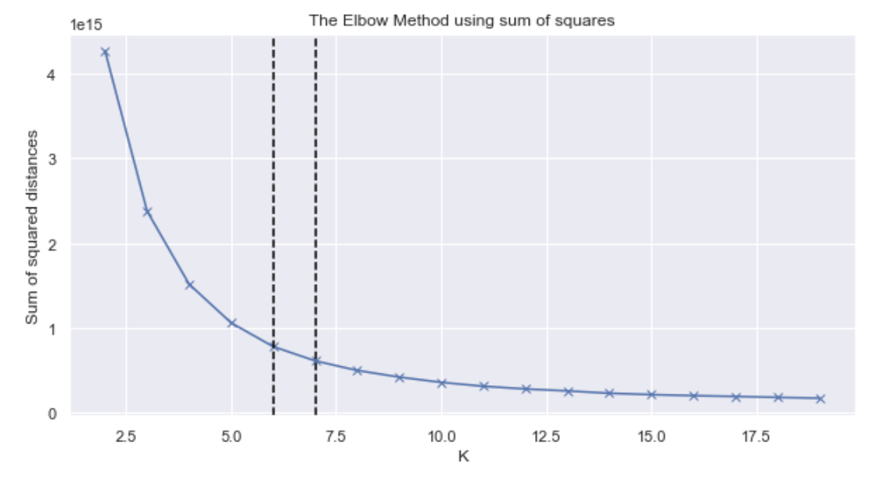

*Fig 18: Elbow method to find the optimal K value*

### Kneed package

Visually inspecting the plot to identify the Knee/Elbow point could be confusing sometimes, as in our case. We will take help of Kneed package that mathematically computes the Knee/Elbow point.

For our dataset, Kneed package has returned K=6 as the knee point.

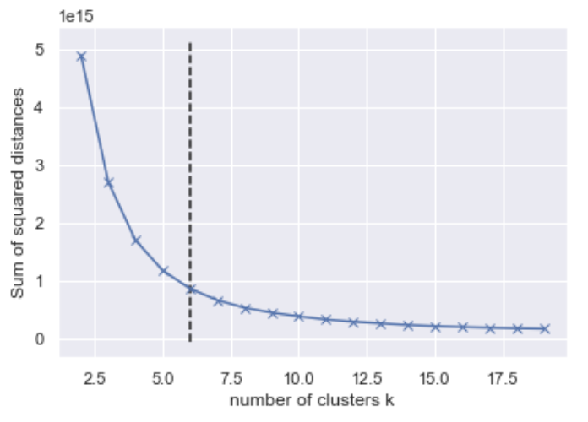

*Fig 19: Kneed package output shows K=6*

### Silhouette coefficient plot

The silhouette plot displays a measure of how close each point in one cluster is to points in the neighboring clusters and thus provides a way to assess parameters like number of clusters visually. Silhouette coefficients near +1 indicate that the sample is far away from the neighboring clusters. A value of 0 indicates that the sample is on or very close to the decision boundary between two neighboring clusters and negative values indicate that those samples might have been assigned to the wrong cluster.

For our dataset we will pick K=6, as Silhouette coefficient plot shows a smaller number of datapoints assigned to the wrong cluster compared to K=7.

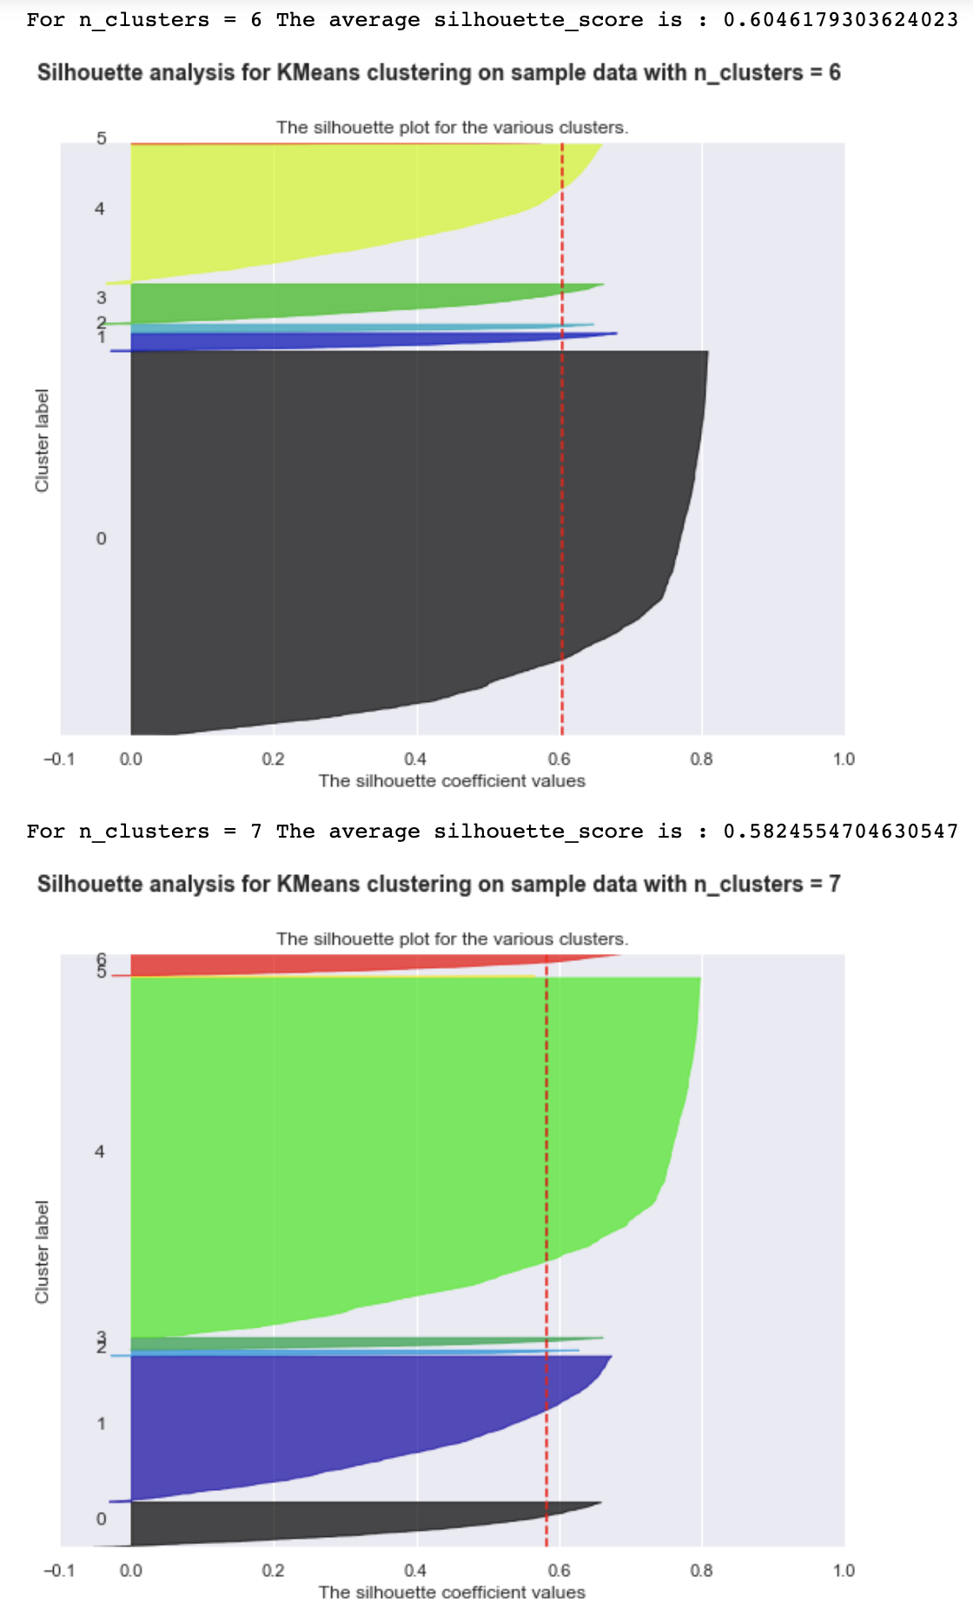

*Fig 20: Plot of Silhouette coefficients of all the data points for K=6 & K=7*

## **K-Means Clustering**

Applying the model with K=6, results in 6 subgroups with distribution of grids as shown below,

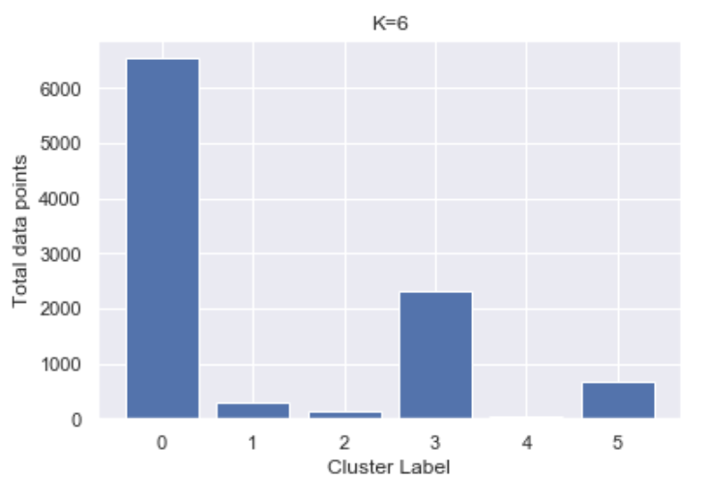 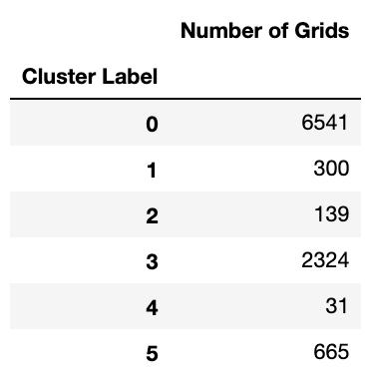

*Fig 21: Subgroups after K-Means Clustering with K=6*

## **Visualization of K Clusters**

### Principal Component Analysis

Displaying the clusters in subgroups in 101 dimensions is not possible. We will reduce the dimensions to 2 dimensions using Principal Component Analysis [PCA] in order to visualize the datapoints in subgroups.



*Fig 22: Visualization of the datapoints in its subgroups*

### GEOJSON

Subgroup labels and grid id are extracted and converted to geojson format with color properties added for each subgroup. This geojson is then displayed on the map. The subgroups are created based on the volumes of telecommunication activities in each grid. Notice how all our top 10 grids are in the red grids. They are also likely to be related to the population distribution of the region.

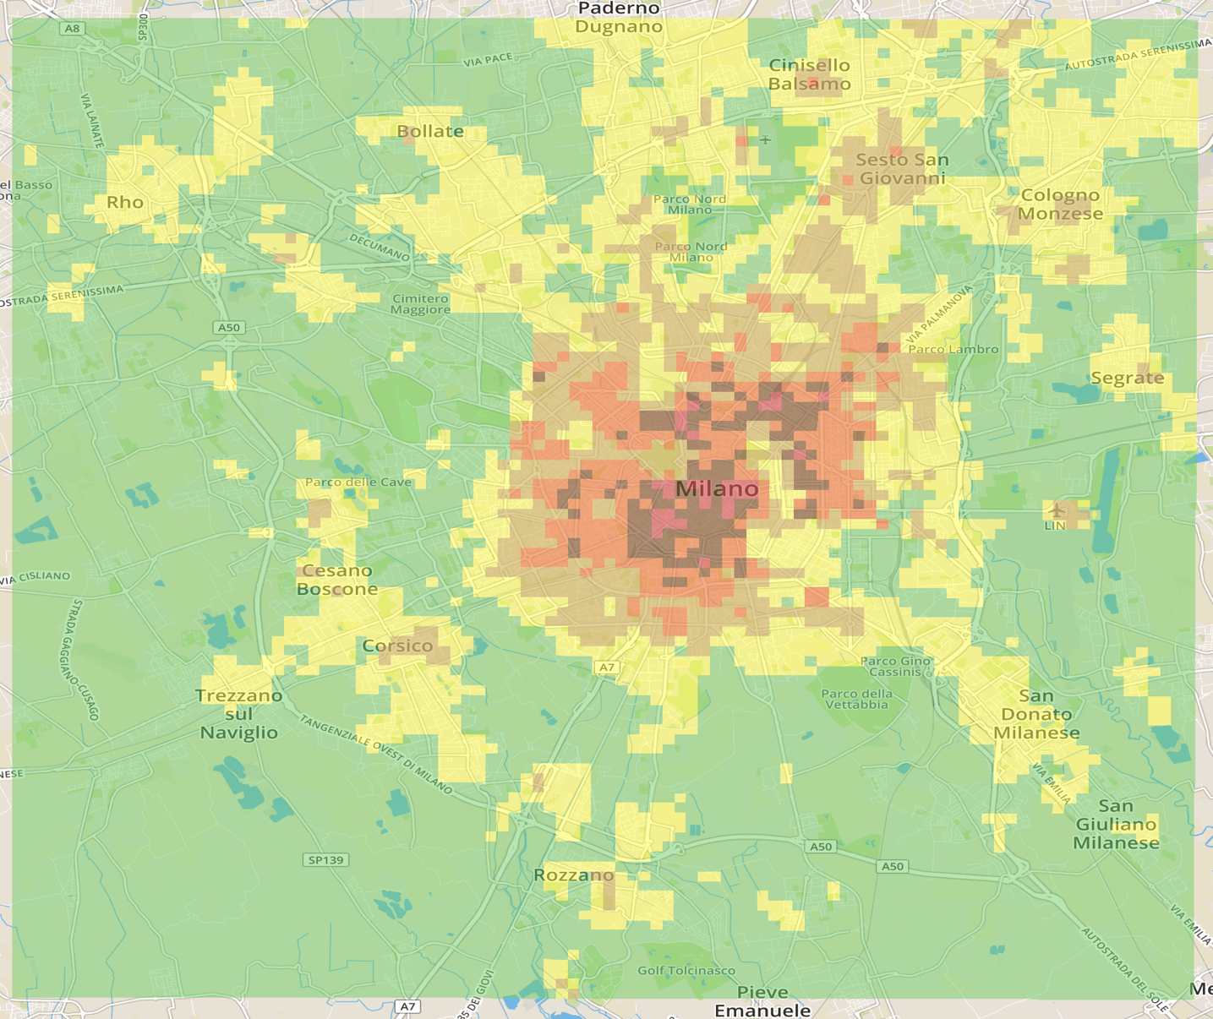

*Fig 23: Visualization of 10000 grids clustered into 6 subgroups*

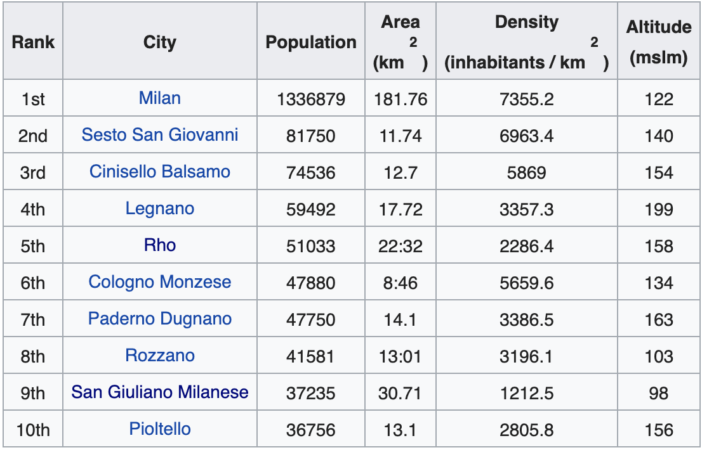

*Fig 24: Largest municipalities by population of Milan [sourced from Wikipedia]*

## **Analysis of K Clusters**

Clusters are plotted against different dimensions. Subgroups from the clustering model shows defined volume ranges for each dimension. Presence of outliers indicates wrong assignment of the data points to a subgroup with respect to that dimension alone. In general, this clustering model has done well for Internet volumes. In case of SMS & Calls Cluster1, Cluster5 & Cluster3 are clearly formed with few outliers only.

T-tests and one-way ANOVA tests can be performed on the subgroups for different dimensions in order to understand the similarities and dissimilarities in their behavioral patterns.

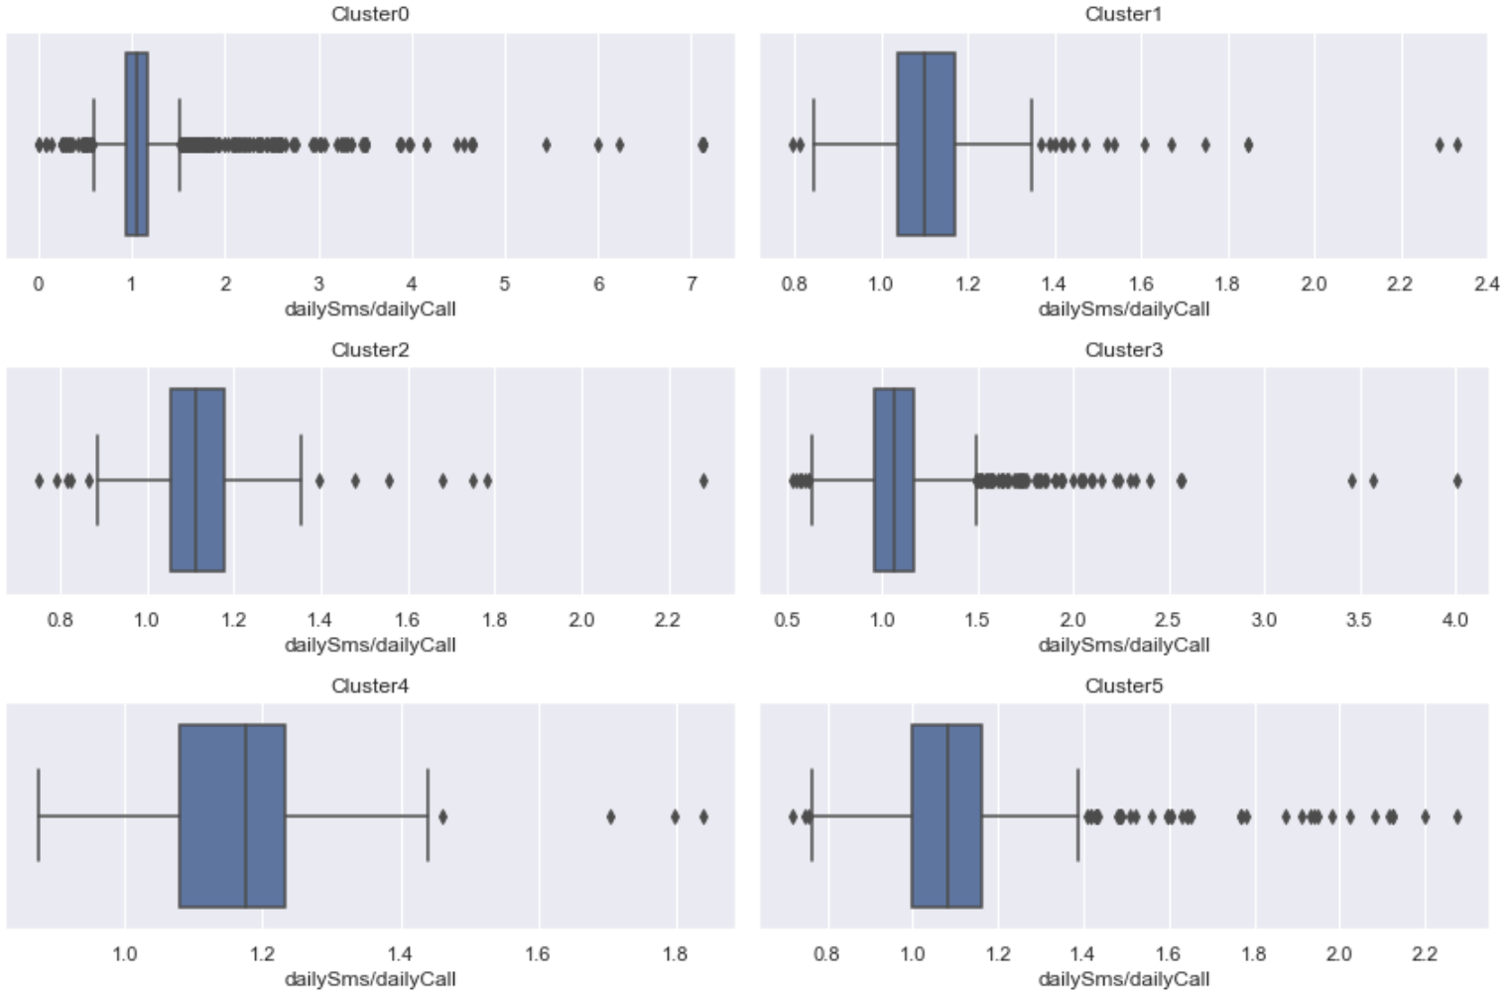

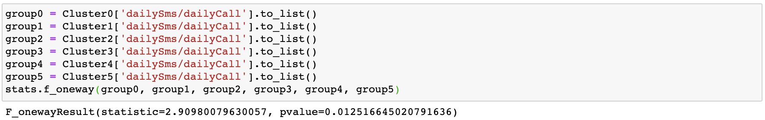

*Fig 25: Box-plot of 6 subgroups and its dailySms/dailyCall feature. One-Way ANOVA test shows different mean value for all the groups*

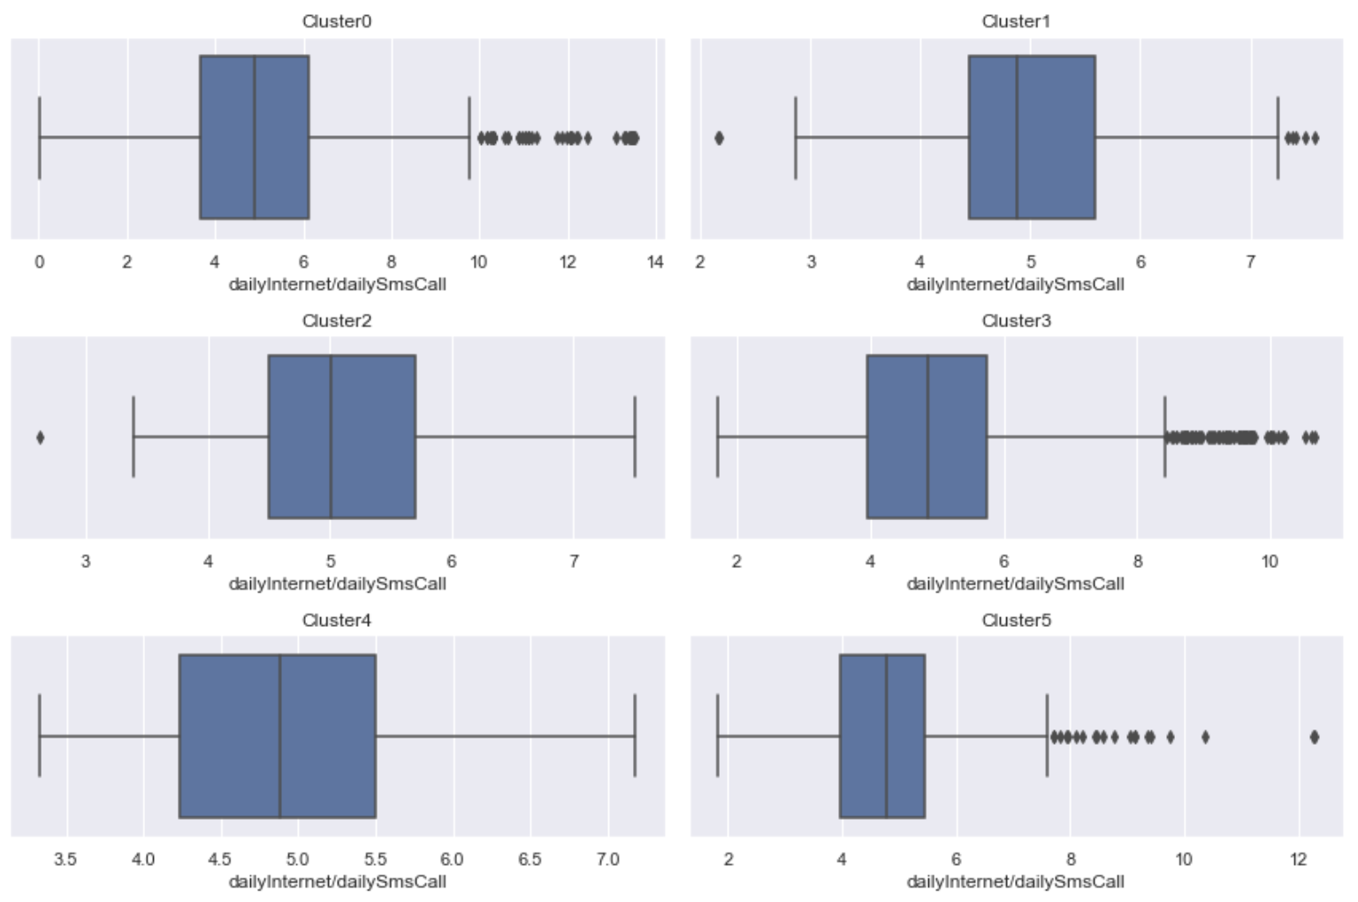

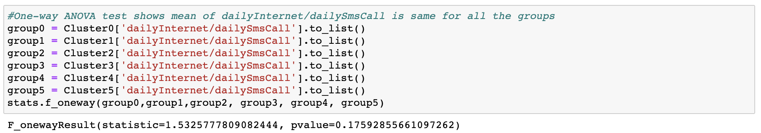

*Fig 26: Box-plot of 6 subgroups and its dailyInternet/dailySmsCall feature. One-Way ANOVA test shows approximately same mean value all the groups*

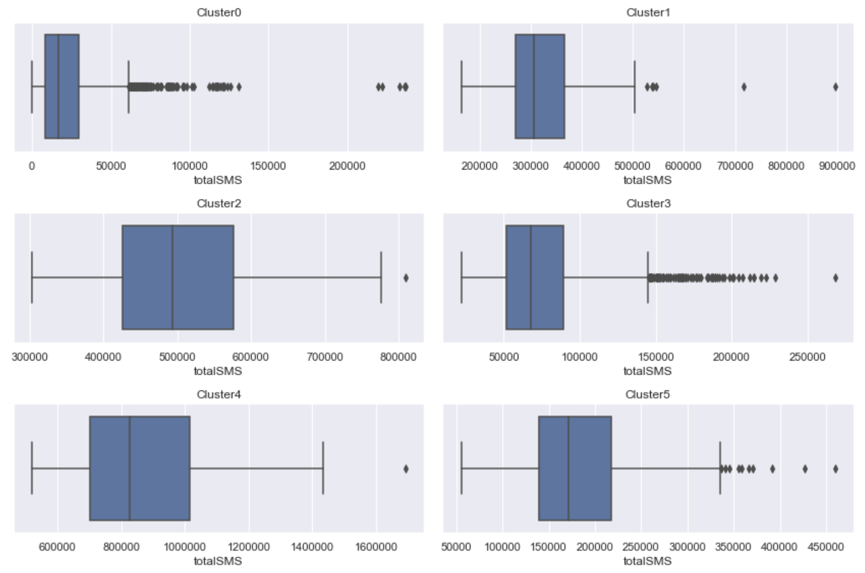

*Fig 27: Box-plot of 6 subgroups and its totalSMS feature*

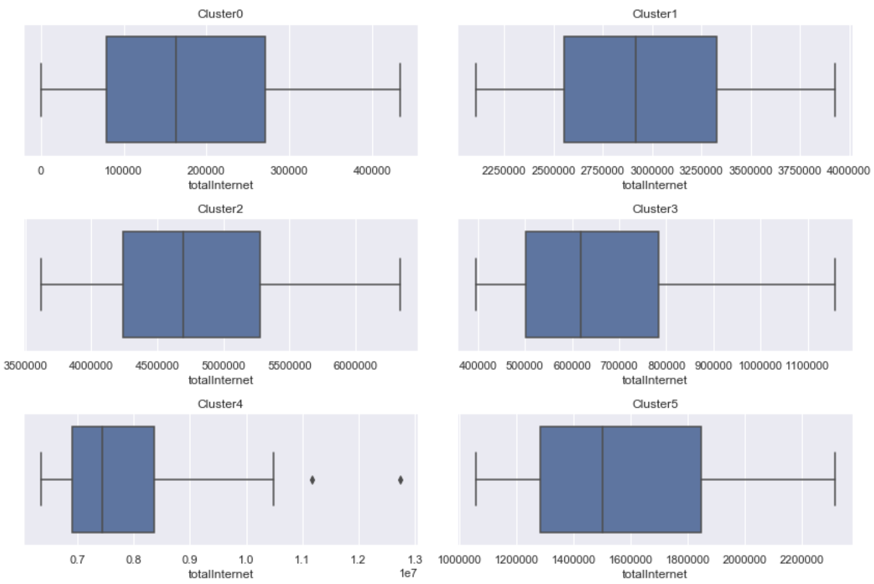

*Fig 28: Box-plot of 6 subgroups and its totalCall feature.*

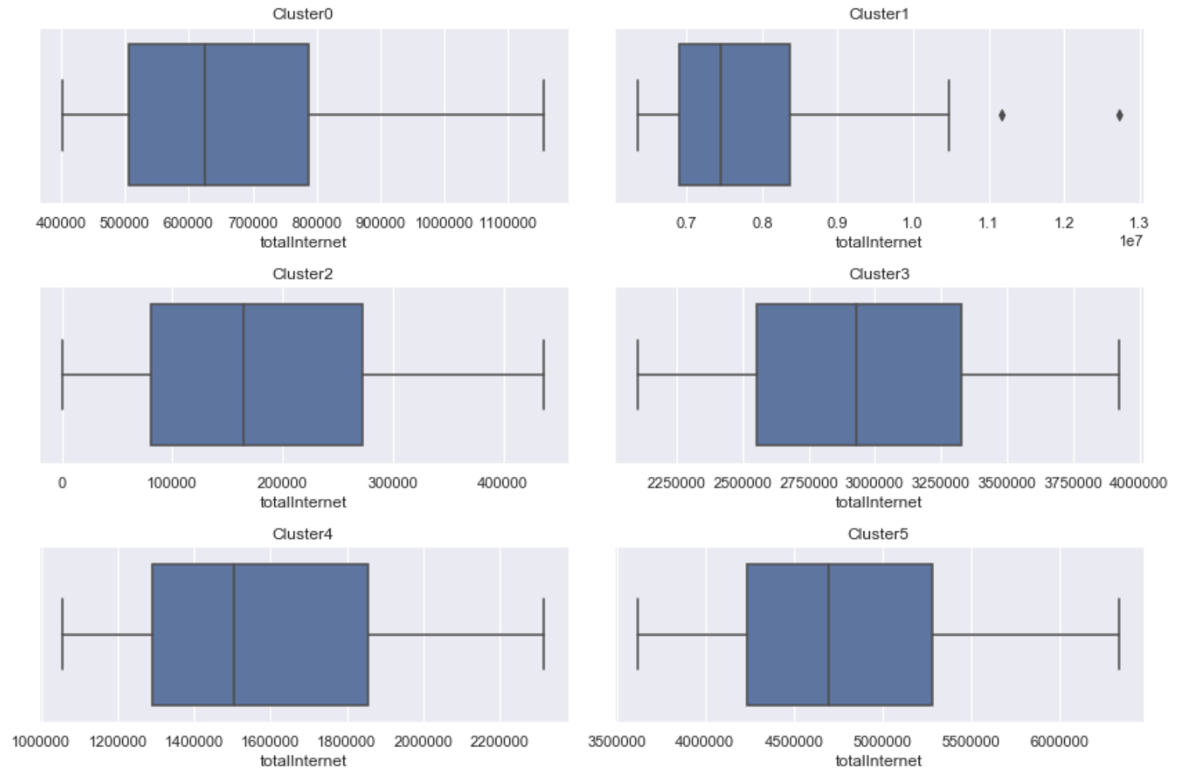

*Fig 29: Box-plot of 6 subgroups and its totalInternet feature*

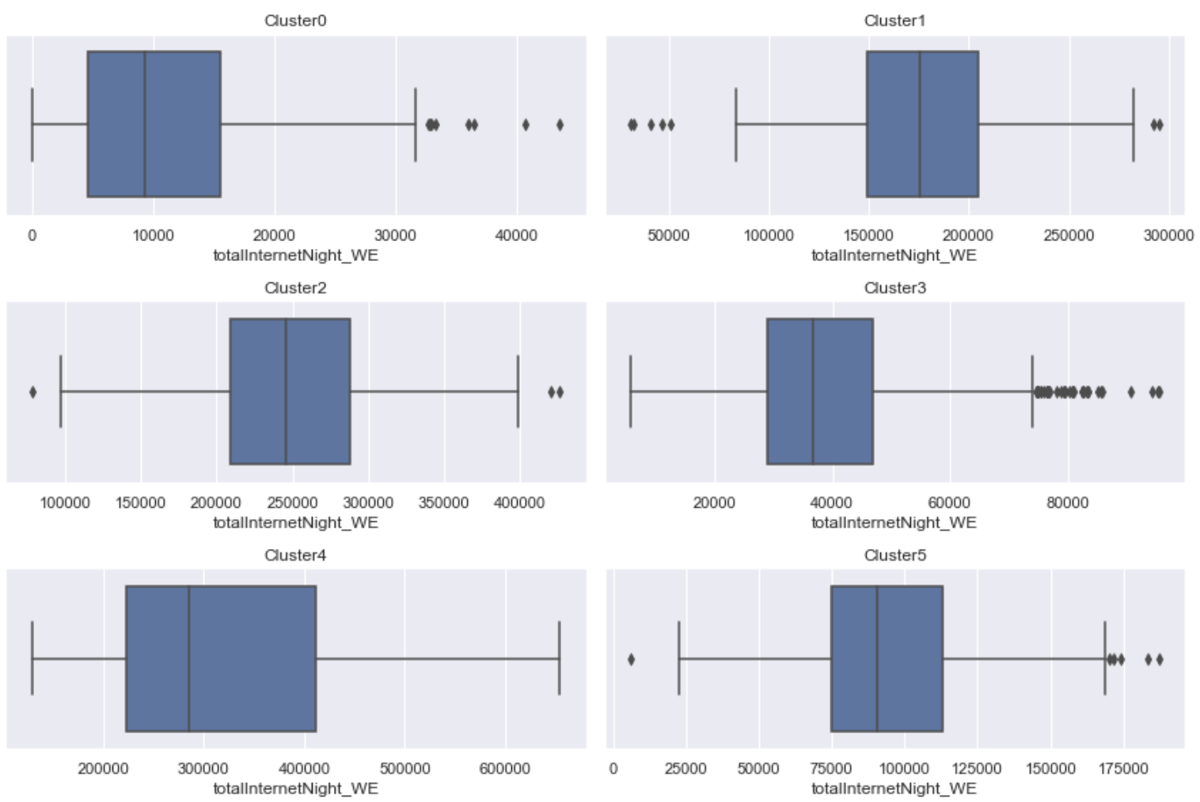

*Fig 30: Box-plot of 6 subgroups and its totalInternetNight_WE feature*

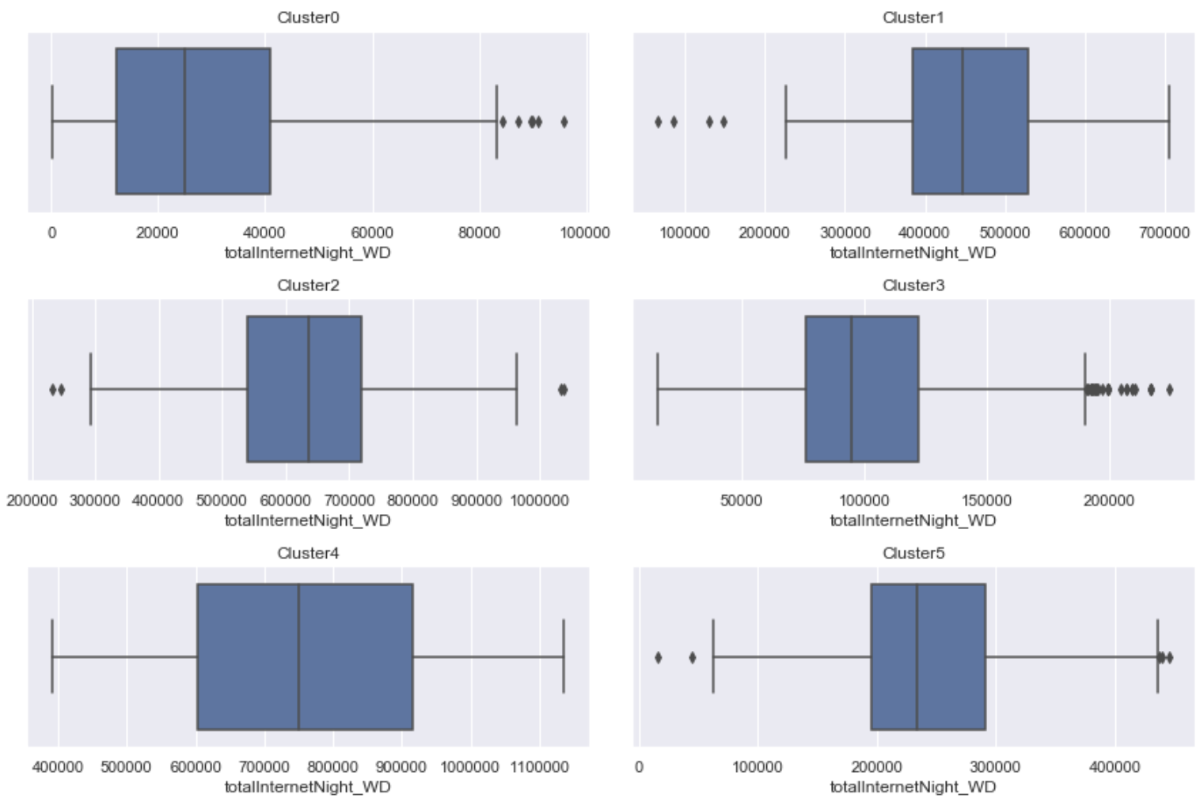

*Fig 31: Box-plot of 6 subgroups and its totalInternetNight_WD feature*

# MACHINE LEARNING: TIME SERIES FORECASTING

Our dataset provides 62 days of historical data that is temporally aggregated every 10 min. Each observation holds information about the volume of telecommunication activities performed over the next 10 min. We have resampled and aggregated this data to daily frequency and hourly frequency.

## **SARIMA Model**

We will be forecasting 7 days of daily Internet volumes for grid 5161, which is is very close to Duomo, city center and it generates highest volumes of Internet activity compared to other grids.

Hourly volumes display multiple seasonality, 24 hours & 7 days and the model that we will be using does not support multiple seasonality.

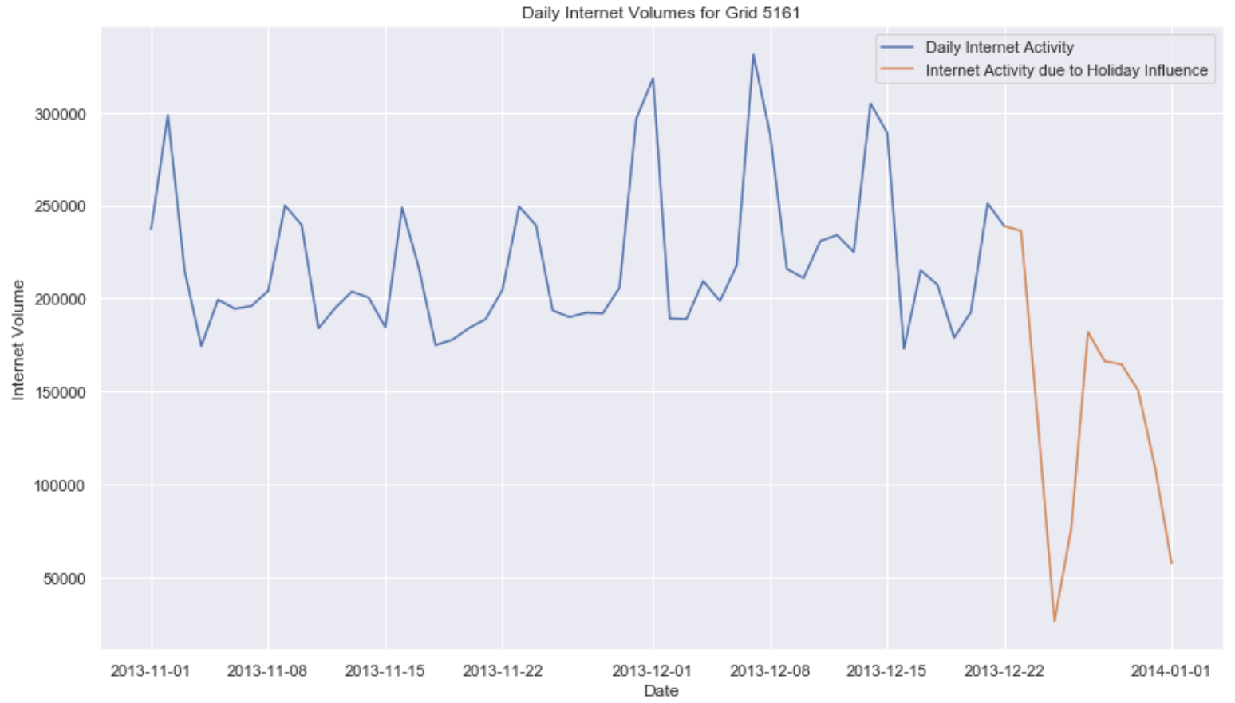

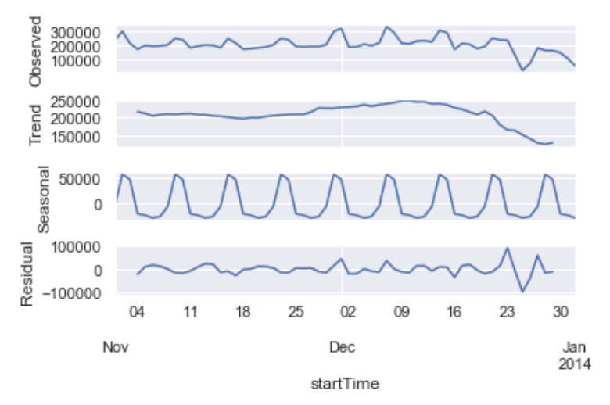

*Fig 32: Time Series and time series decomposition plot of daily internet volumes for grid 5161*

### Time Series Decomposition

Plot of daily volumes and its time series decomposition in Fig 31 & Fig 32 shows seasonal effect for every 7 days. Volumes reaches new peaks during weekends and goes down during weekdays. In order to incorporate this seasonality, we will use ARIMA model with seasonal component, SARIMA [Seasonal Autoregressive Integrated Moving Average]. Also, the trend starts to drop after Dec 23rd due to the influence of holiday.

### Hyperparameter Tuning

Augmented Dickey Fuller Test (ADF) is [unit root](https://www.statisticshowto.datasciencecentral.com/unit-root/) test for [stationarity](https://www.statisticshowto.datasciencecentral.com/stationarity/).

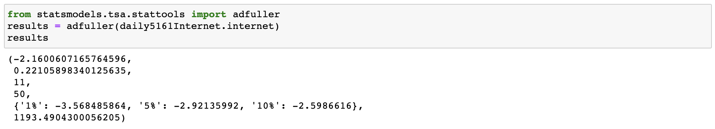

1st element of the result is the p-value which is > 0.05, hence our dataset is not stationary. A first order differencing will fix it.

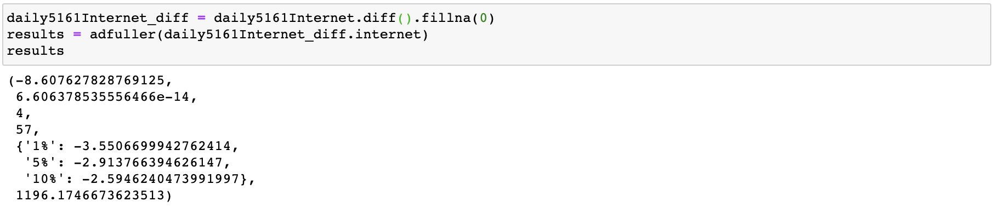

1st element of the result is the p-value which is < 0.05, so we reject the null hypothesis of Augmented Dicky fuller test. Dataset is stationary now.

We will set d =1 and rest of the hyperparameters of SARIMA model is obtained using auto_arima function from package pmdarima.

The downward trend from Dec 23, 2013 to Jan 1, 2014 will result in skewed forecasting for the next 7 days, Fig 33. We should not be seeing volumes as low as forecasted and also the model mistakes the drop on Jan 1st as a weekend behavior. But we do not have data from previous years to see how the pattern is for the first week of January to understand the exact behavior. Hence, we will assume that Holiday effects will wear out during first week of January.

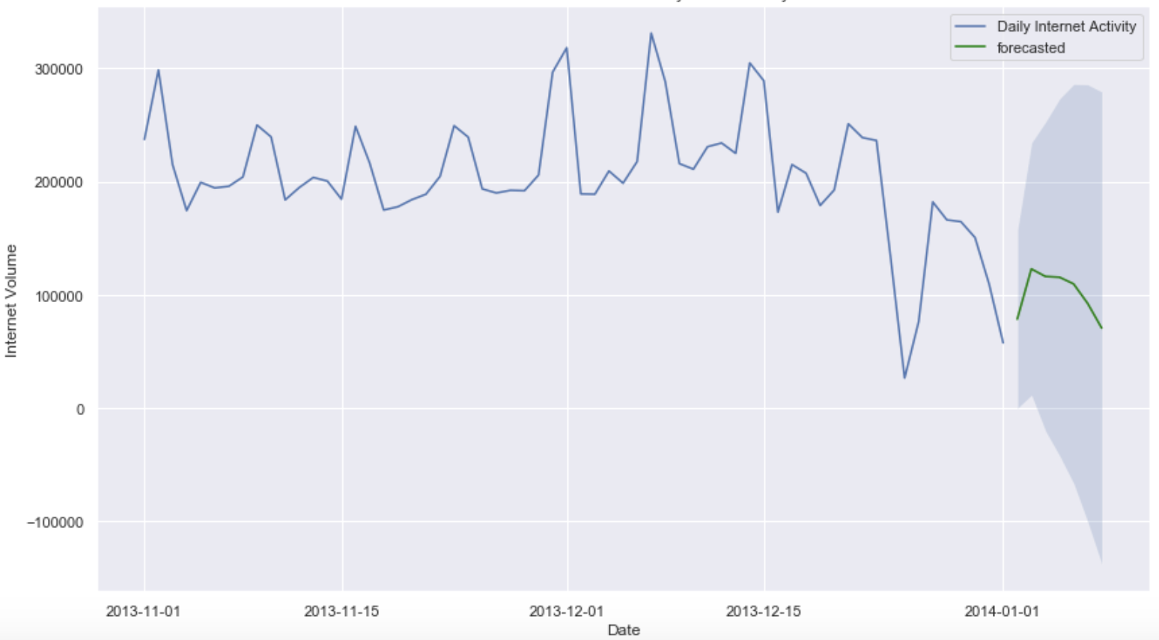

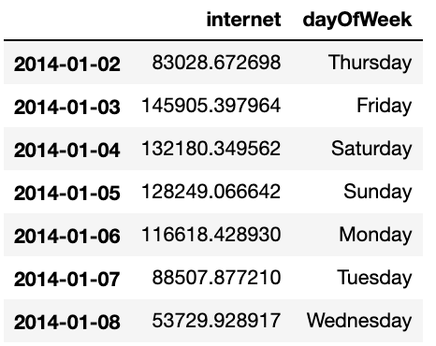

*Fig 33: Skewed forecast for first week of January due to holiday influence*

Our approach to this situation will be as follows,

1. Remove data that shows heavy holiday influence which is from Dec 23, 2013 to Jan 1, 2014. In our dataset these are outlier data points. [Fig 34]
2. Once we remove values from Dec 23, 2013 to Jan 1, 2014, it needs to be filled with some data before forecasting for first week of January. Hence, we will predict volumes for these days as though they were regular days with no holiday effect. [Fig 35]
3. Now with this new dataset we will forecast for the first week of January. [Fig 37]

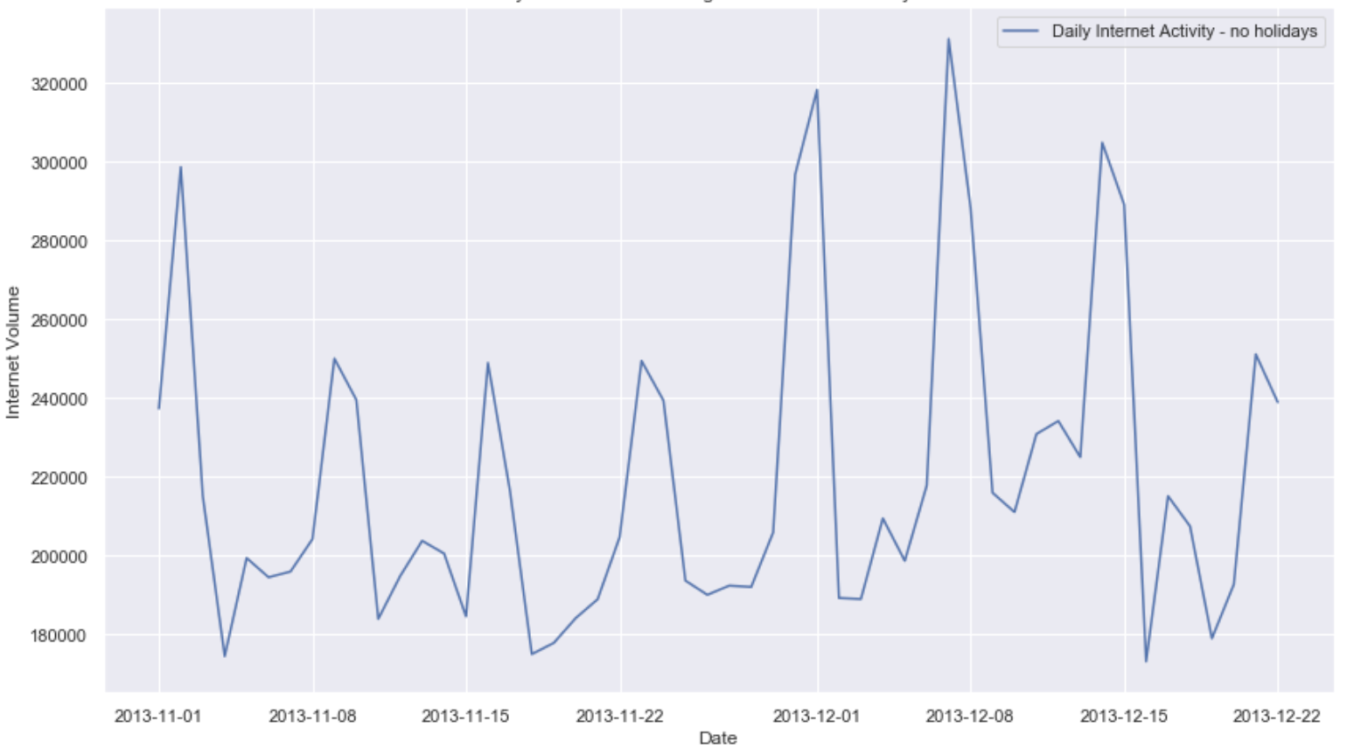

*Fig 34: Time Series plot of daily internet volumes for grid 5161 with deleted holiday influence data*

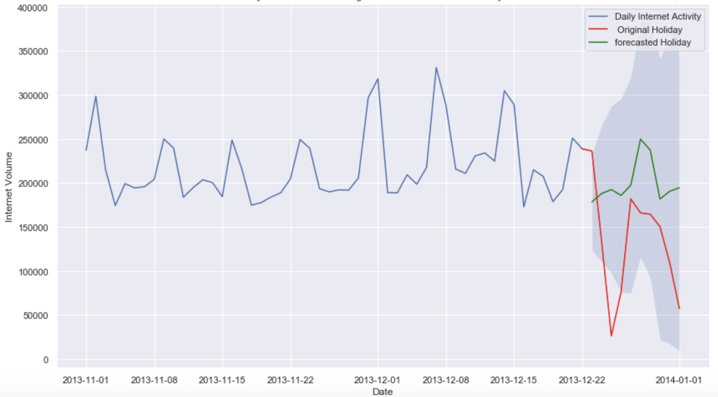

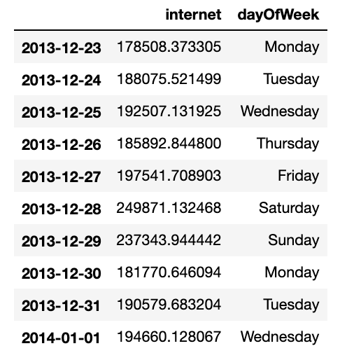

*Fig 35: Holiday data being replaced by predicted data*

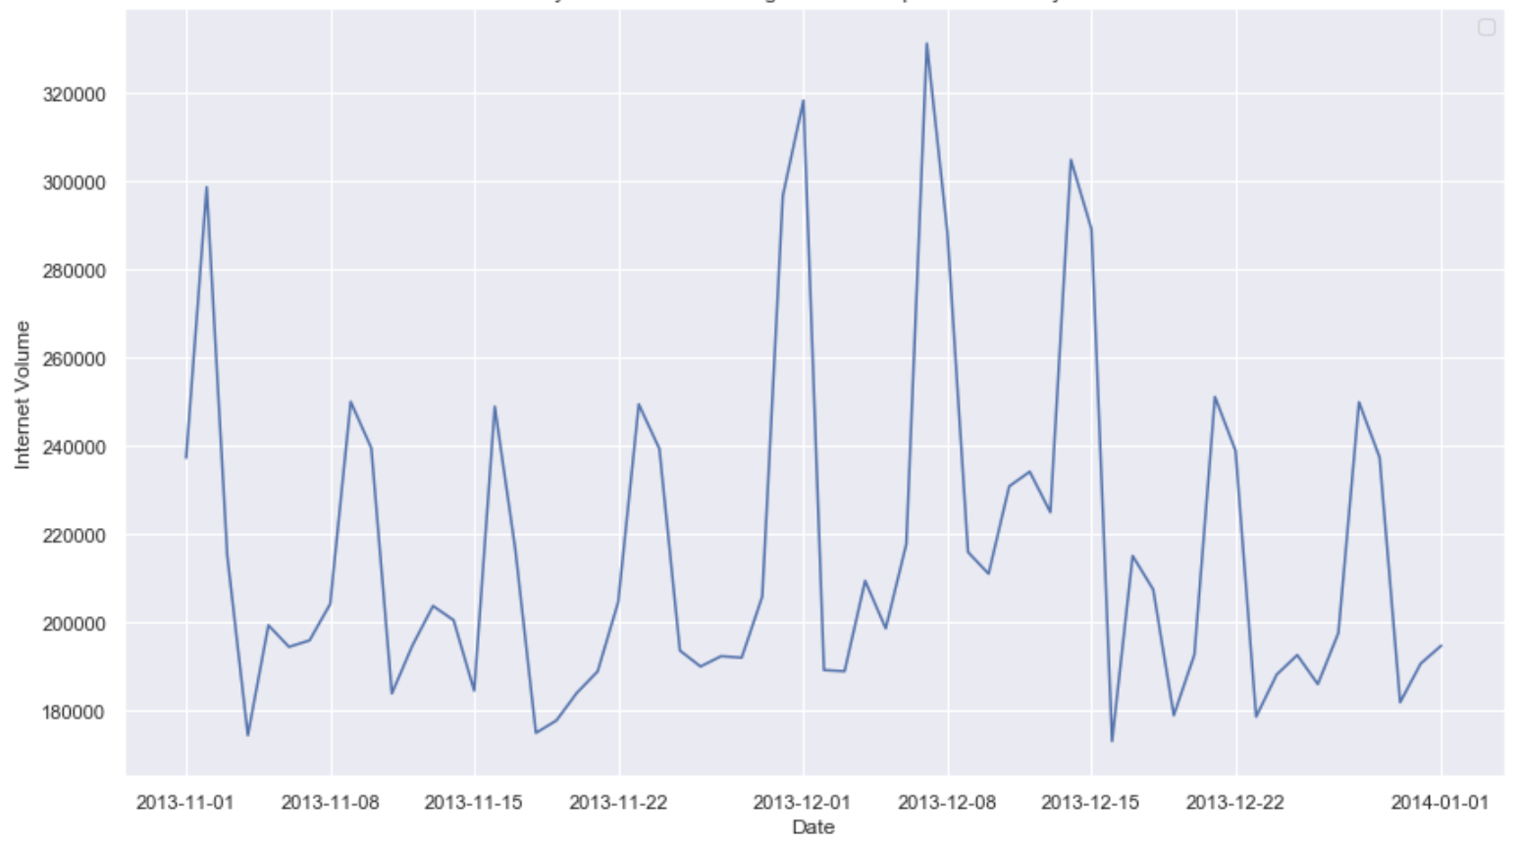

*Fig 36: Time Series plot of daily internet volumes for grid 5161 with predicted holiday data*

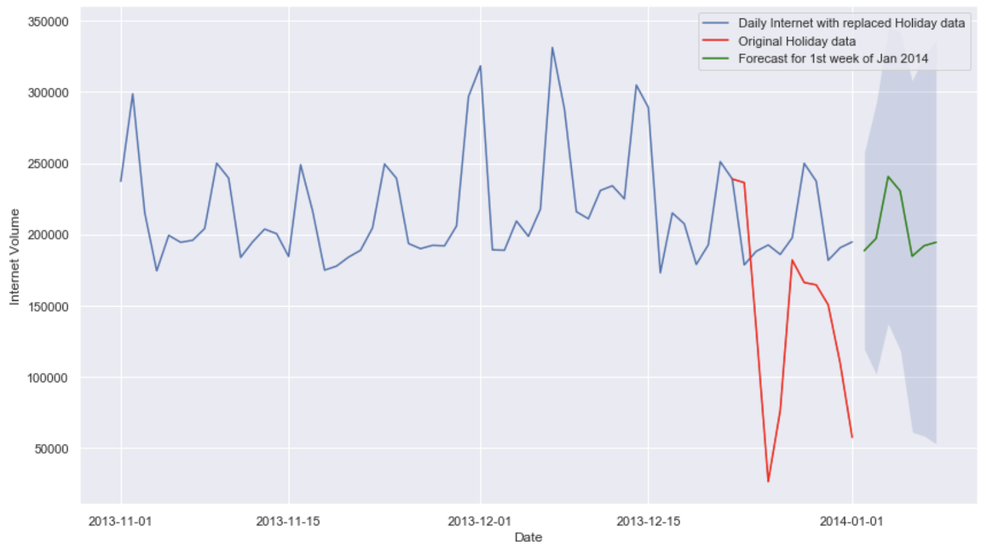

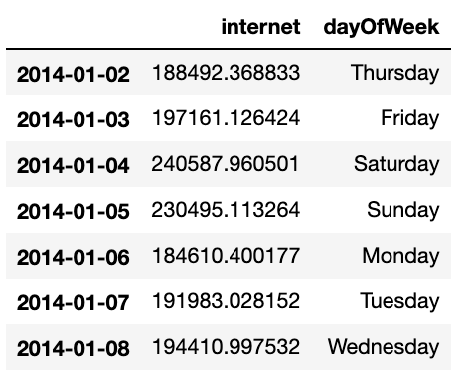

*Fig 37: Time Series forecast of daily internet volumes for grid 5161 for first week of January,2014 with replaced holiday data*

### Model Evaluation

After identifying the parameter values using auto_arima(), we fit our model on the new dataset, and use it to evaluate its accuracy by predicting volumes for days whose volumes are known. This is the evaluation on training data.

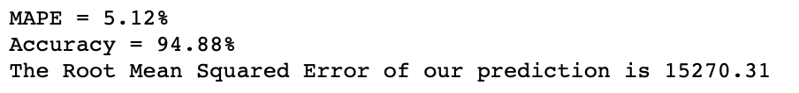

*Fig 38: Model Evaluation*

Since we do not have data for first week of Jan 2014, we cannot evaluate the model for test data. We have assumed that during first week of Jan Holiday effects wears out and people return their to regular schedule.

# CITATIONS

* [Barlacchi, G. et al. A multi-source dataset of urban life in the city of Milan and the Province of Trentino. Sci. Data2:150055 doi: 10.1038/sdata.2015.55 (2015).](https://www.nature.com/articles/sdata201555)
* Telecom Italia, 2015, "Telecommunications - SMS, Call, Internet - MI", <https://doi.org/10.7910/DVN/EGZHFV>, Harvard Dataverse, V1
* Telecom Italia, 2015, "Milano Grid", <https://doi.org/10.7910/DVN/QJWLFU>, Harvard Dataverse, V1

# REFERENCES

* How to use geojson - <https://www.twilio.com/blog/2017/08/geospatial-analysis-python-geojson-geopandas.html>
* Code for Silhouette Score Plot - <https://scikit-learn.org/stable/auto_examples/cluster/plot_kmeans_silhouette_analysis.html>